**Cartes de sous**

**Fiche 53a**

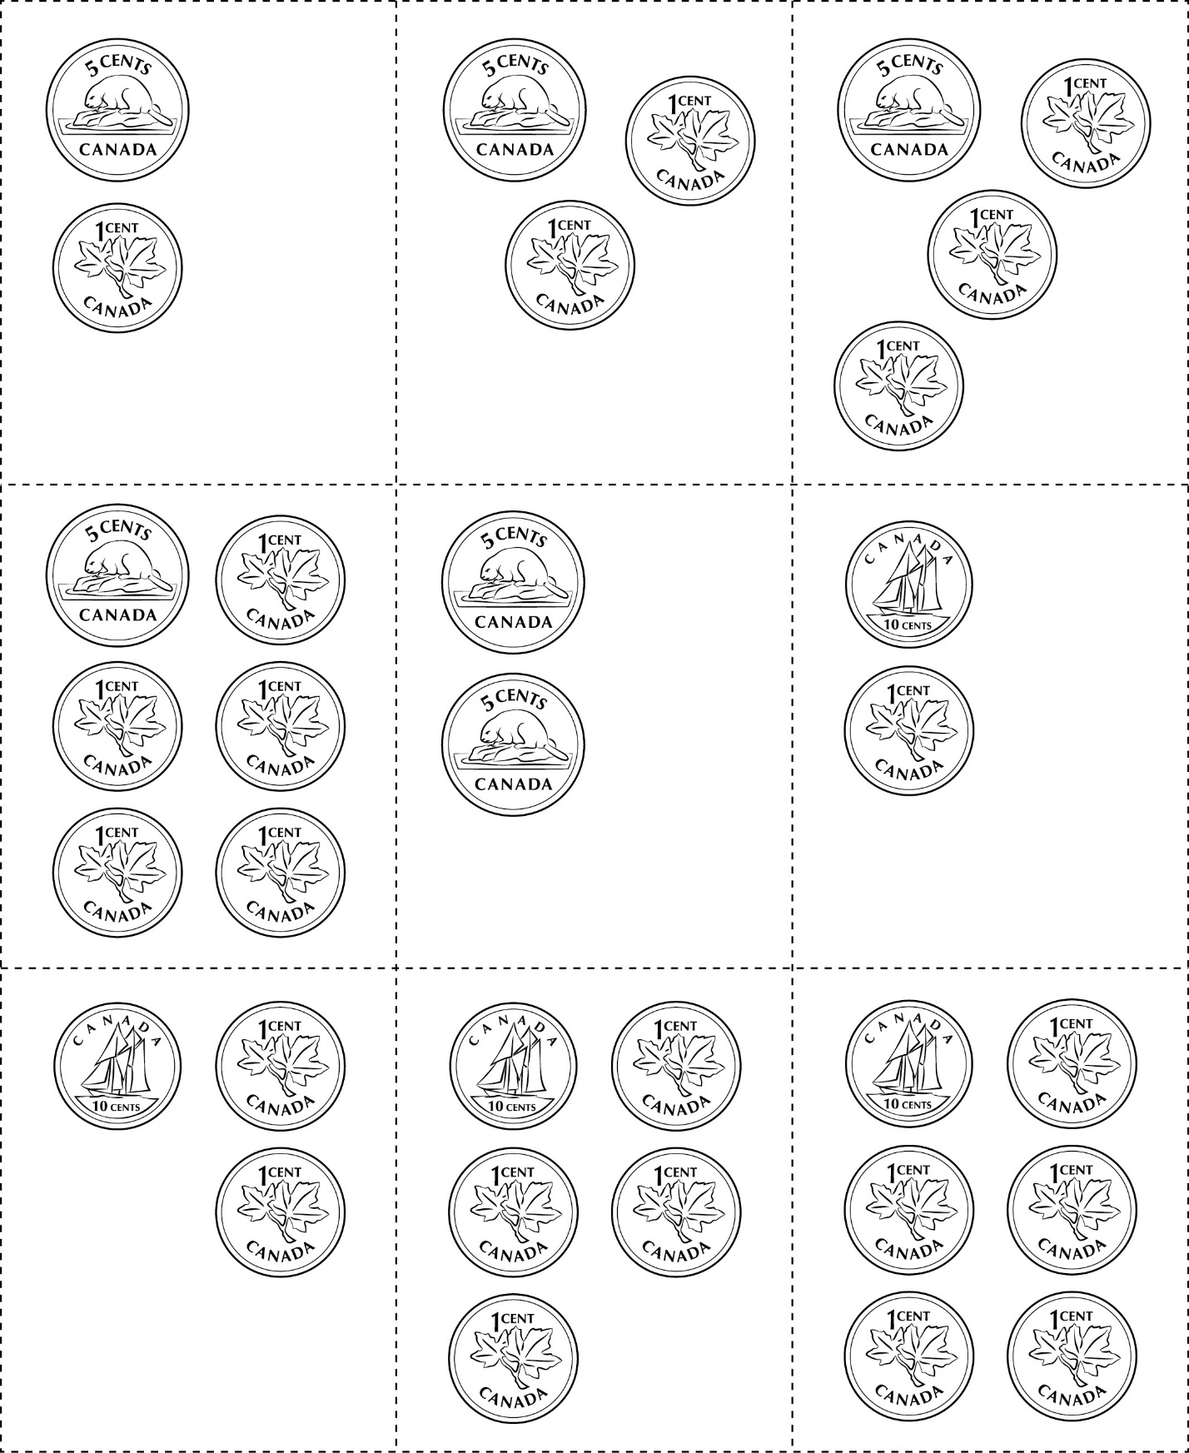



**Cartes de sous**

**Fiche 53b**

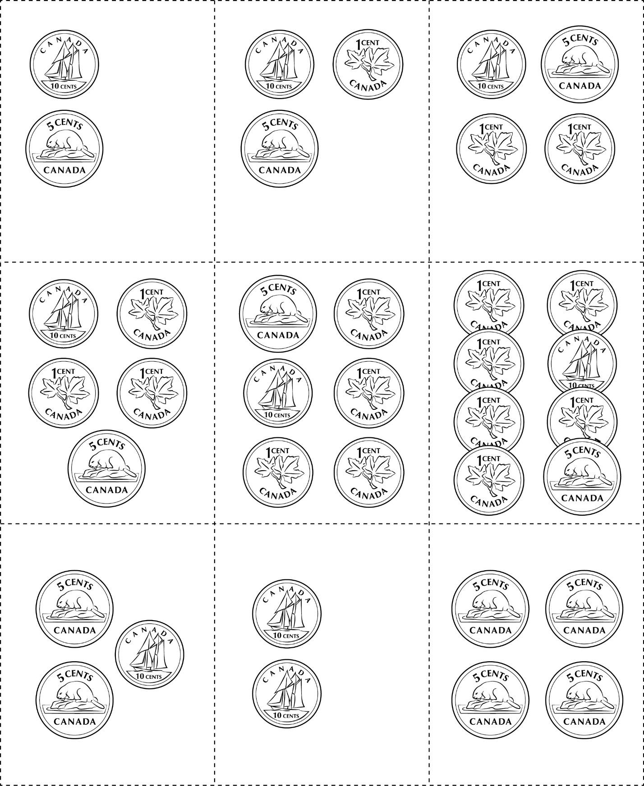

**Cartes de sous**

**Fiche 53c**

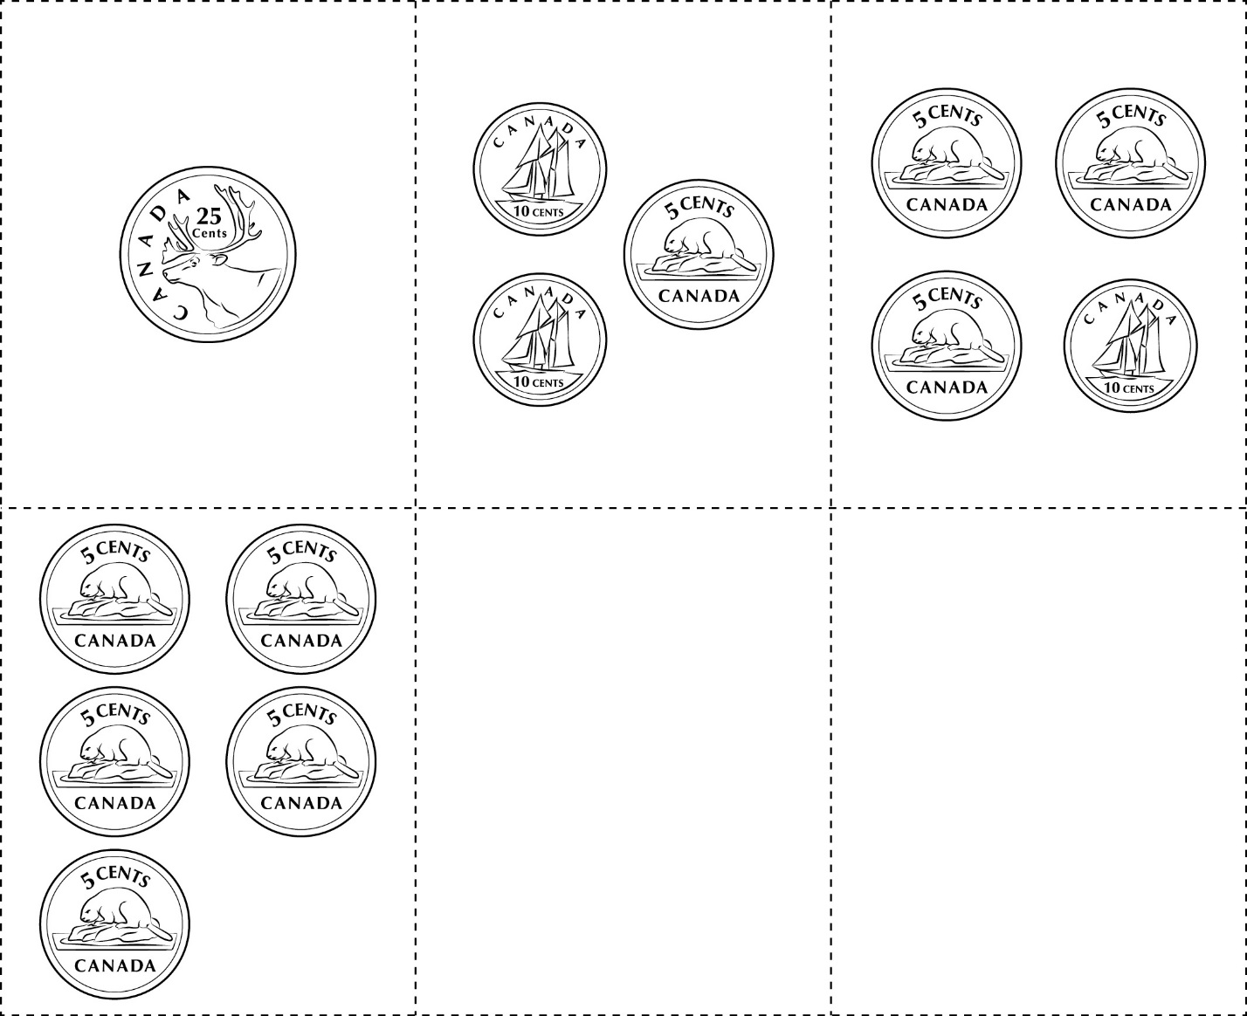

**Cartes de sous**

**Fiche 53d**



|  |  |  |
| --- | --- | --- |
|  |  |  |
|  |  |  |
|  |  |  |

**Cartes de sous**

**Fiche 53e**

(pour l’extension)

|  |  |  |
| --- | --- | --- |
|  |  |  |
|  |  |  |
|  |  |  |

**Cartes de sous**

**Fiche 53f**

(pour l’extension)

|  |  |  |
| --- | --- | --- |
|  |  |  |
|  |  |  |
|  |  |  |