**Semer des graines**

**Fiche 60**

**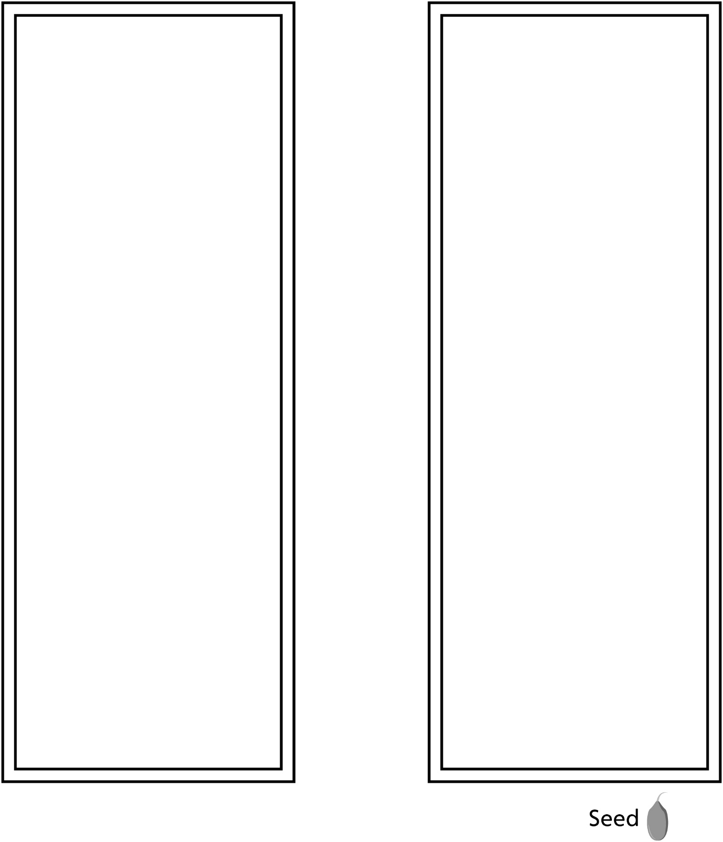**

**Graine ../../../Mathology%202/BLM%20WORKING%20FILES/Batch%204_BLM%20working%20files/Batch%204_Jpegs/fg01_n07_a32_ma2_blm.jp**