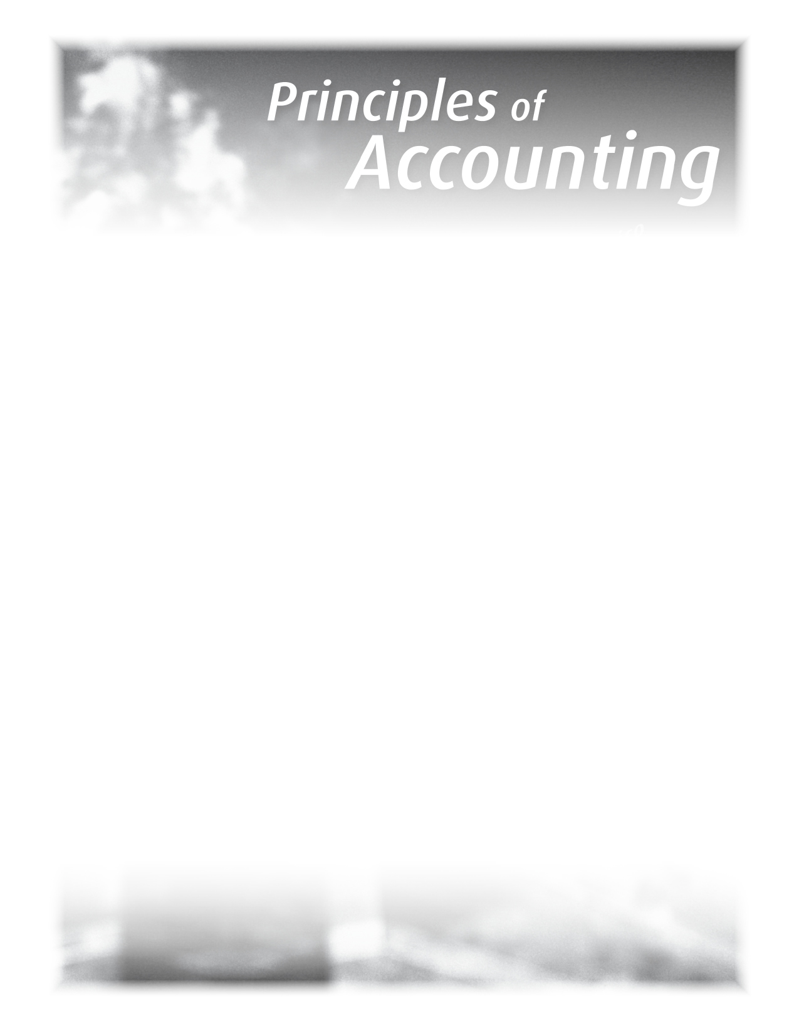

A message from the Accounting teacher

RE: Principles of Accounting, 3rd Edition
September 2012

Dear Parent,

Our school is using Principles of Accounting 3rd Edition as the textbook for the Grade 11 Accounting course. There are a set of Working Papers that compliment the textbook and provide workspace and templates in support for the course work. The Ontario Ministry of Education no longer allows schools to request payment for workbooks and/or working papers from parents. If you would like to support your child’s coursework in Accounting by purchasing the Working Papers, you may purchase them directly from the publisher, Pearson Canada.
Purchasing Information:

Order number (ISBN):
Principles of Accounting 3rd Edition: 0130341037

Customer Service Tel: 1-800-361-6128

Online: www.pearsoncanada.ca/accountingworkingpapers

The purchase of the Working Papers is not mandatory for course completion; it will simply make it easier for your child to work through the assignments.
Wishing you all the best as your child begins the new school year.
Regards,

Accounting Teacher

