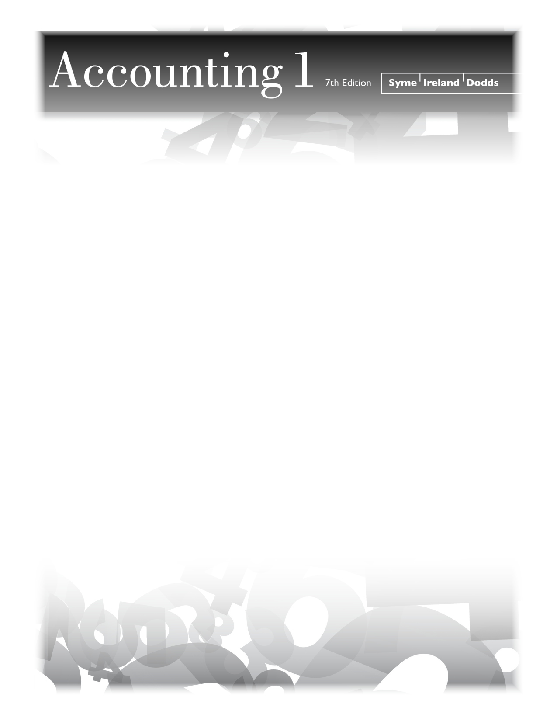

A message from the Accounting teacher
September 2019
Dear Parent
Our school is using Accounting 1 7th Edition as the textbook for the Grade 11 Accounting course. There is a Workbook that compliments the textbook and provides workspace and templates in support for the course work. The Ontario Ministry of Education no longer allows schools to request payment for workbooks from parents. If you would like to support your child’s coursework in Accounting by purchasing the Workbook, you may purchase it directly from the publisher, Pearson Canada.
Purchasing Information:

Order Number (ISBN): 9780132667654

Customer Service Tel: 1-800-361-6128
Online: www.pearsoncanada.ca/accounting1workbook

The purchase of the Workbook is not mandatory for course completion; it will simply make it easier for your child to work through the assignments.
Wishing you all the best as your child begins the new school year.
Regards,

Accounting Teacher

