How to open apps not from Mac App Store

- Open System Preferences.
- Go to the Security & Privacy tab.
- Click on the lock and enter your password so you can make changes.
- Change the setting for 'Allow apps downloaded from' to 'App Store and identified developers' from just App Store.
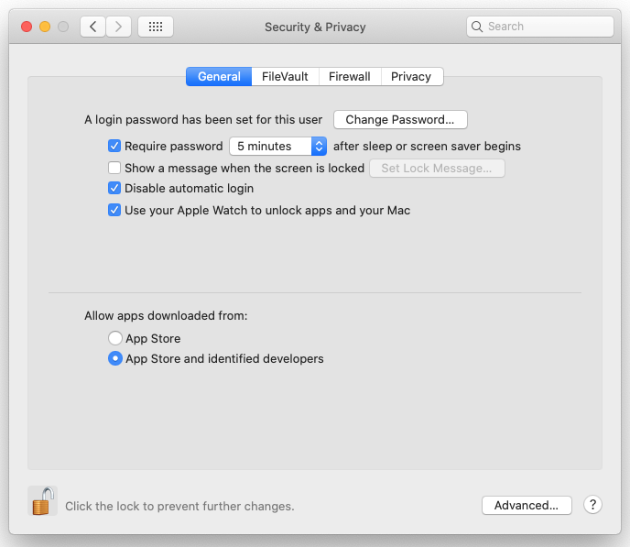

How to open a blocked app
- Open System Preferences.
- Go to Security & Privacy and select the General tab.
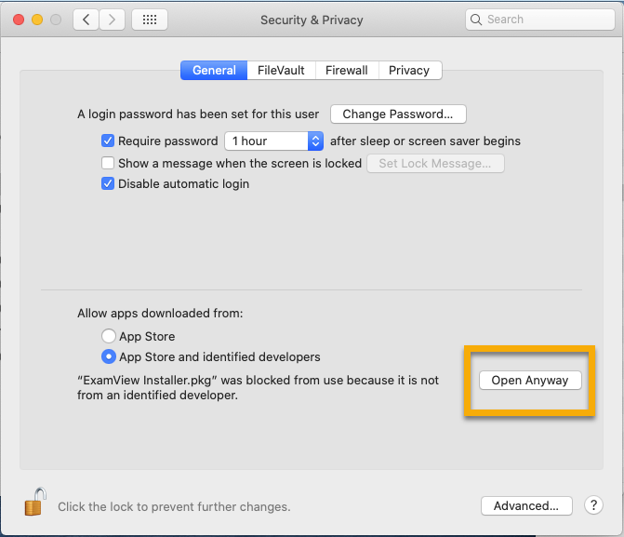

- If you've been blocked from opening an app within the past hour, this page will give you the option to override this by clicking the temporary button 'Open Anyway'.
- You'll be asked one more time if you're sure, but clicking Open will run the app.
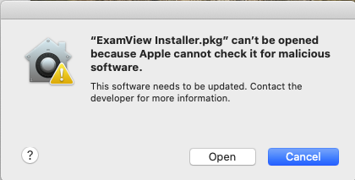
This creates an exception for that app, so you'll also be able to open it in the future without having to repeat this process.

