What’s the Overlap
Shape and Space
Unit 2 Line Master 1a

You will determine the surface area of three composite objects.

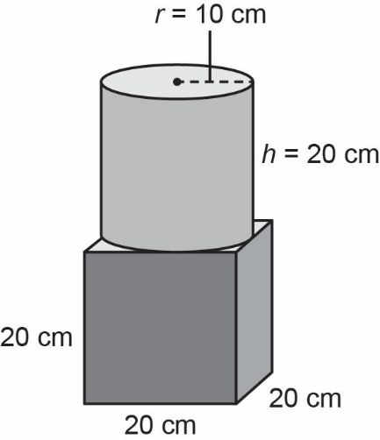
1. a) Determine the surface area of the cylinder.

b) Determine the surface area of the cube.

c) Determine the area of overlap.

d) Subtract the overlap to determine the surface area of the composite object.

What’s the Overlap (cont’d)
Shape and Space
Unit 2 Line Master 1b

2. a) Detemine the surface area of the triangular prism.
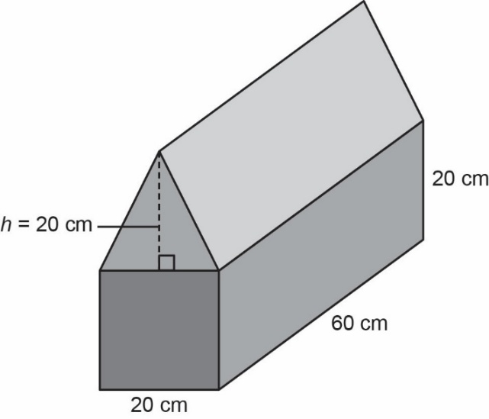

b) Determine the surface area of the
square prism.

c) Determine the area of overlap.

d) Subtract the overlap to determine the surface area of the composite object.

What’s the Overlap (cont’d)
Shape and Space
Unit 2 Line Master 1c

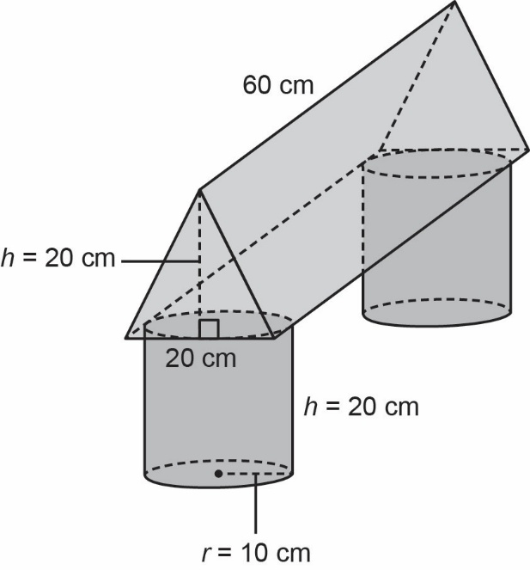
3. a) Determine the surface area of the triangular prism.
(*art not drawn to scale)

b) Determine the surface area of the cylinders.
(*art not drawn to scale)

c) Determine the area of overlap.

d) Subtract the overlap to determine the surface area of the composite object.

