Scale Map of Canada
Shape and Space
Unit 1 Line Master 5

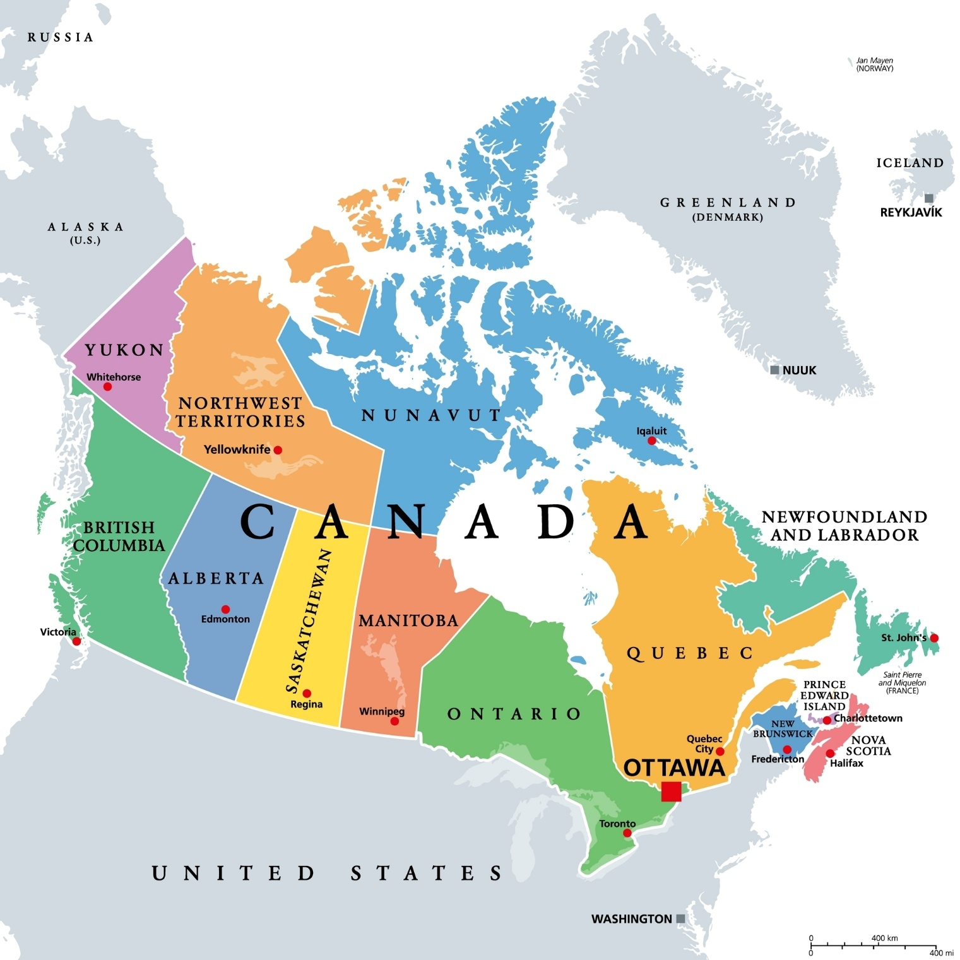
0 km |  | 800 km
1600 km

