Are We Similar?
Shape and Space
Unit 1 Line Master 3a

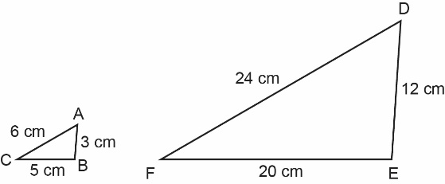
- For each pair of polygons, identify whether they are similar. If they are similar, identify whether the second polygon is a reduction or enlargement of the first polygon and by what scale factor.
Explain your reasoning.
a)

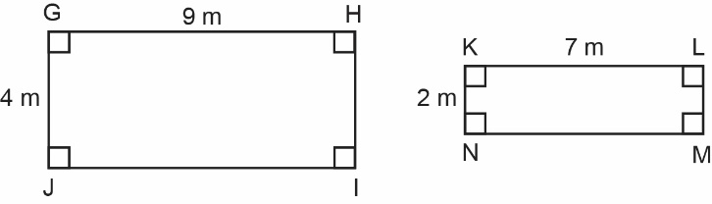
b)

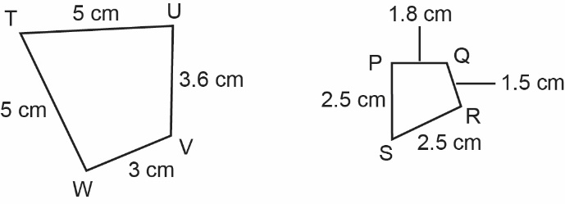
c)

Are We Similar? (cont’d)
Shape and Space
Unit 1 Line Master 3b

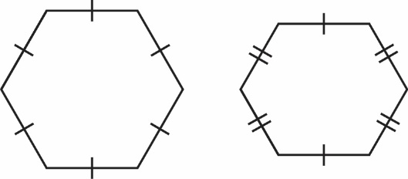
d)

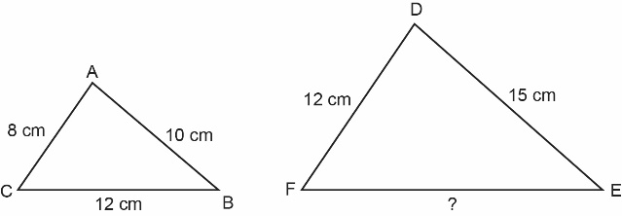
- For each pair of similar polygons, determine the length of the unknown side.
a)

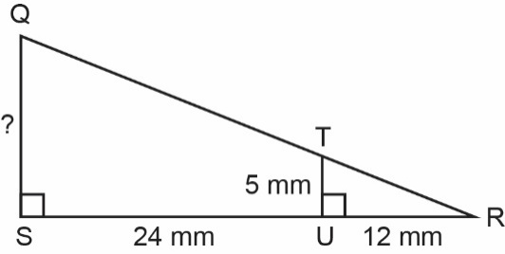
b)

Are We Similar? (cont’d)
Shape and Space
Unit 1 Line Master 3c

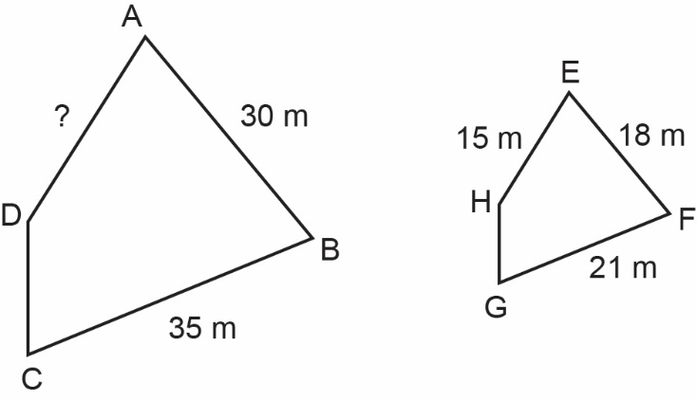
c)

- Draw a triangle that is similar to ∆ABC.
Draw a triangle that is not similar to ∆ABC.
Explain your reasoning.
