Tile Pairs
Shape and Space
Unit 1 Line Master 1

For each pair of tiles, do you think they are similar? Why or why not?

A | B
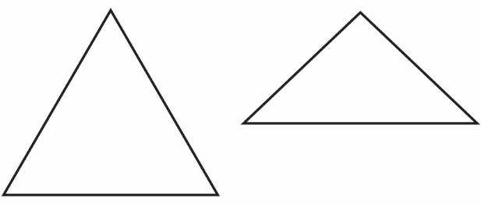 | 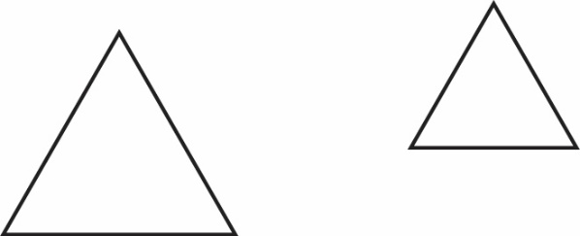
C | D
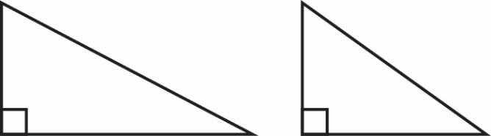 | 
E | F
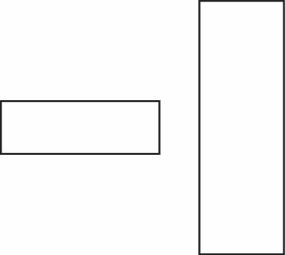 | 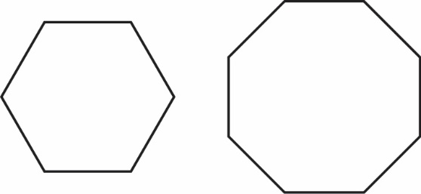
G | H
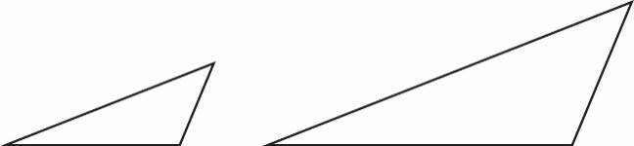 | 