Are You the Solution? Answers
Patterns and Relations
Unit 4 Line Master 4c

1. $x-6≤2$
$x-6+6≤2+6$
$x≤8$
Choose a value less than 8: x = 4
L.S. = $x-6$ R.S.= $2$
= $4-6$
= $-2$
‒2 $≤$2, so the solution is correct.

2. $-2x>32$
$\frac{-2x}{-2}$ < $\frac{32}{-2}$
$x<-16$
Choose a value less than ‒16: x = ‒20
L.S. = $-2x$ R.S.= $32$
= $-2(-20)$
= $40$
40 > 32, so the solution is correct.

3. $-\frac{p}{8}<2$
$8 ×\left(-\frac{p}{8}\right)<2 ×8$
$-p<16$
$p>-16$
Choose a value greater than ‒16: p = 0
L.S. = $-\frac{p}{8}$ R.S.= $2$
= $-\frac{0}{8}$
= $0$
0 < 2, so the solution is correct.

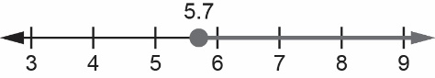
4. $q-3.2≥2.5$
$q-3.2+3.2≥2.5+3.2$
$q≥5.7$
Choose a value greater than 5.7: q = 6
L.S. = $q-3.2$ R.S.= $2.5$
= $6-3.2$
= $2.8$
2.8 $≥$ 2.5, so the solution is correct.
Patterns and Relations
Unit 4 Line Master 4d
Are You the Solution? Answers (cont’d)

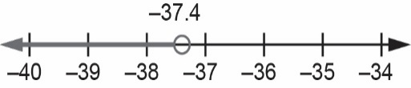
5. $2y+13.3<y -24.1$
$$2y+13.3 -13.3<y -24.1-13.3$$
$2y<y -37.4$
$2y-y<y-y -37.4$
$y<-37.4$
Choose a value less than ‒37.4: y = ‒40
L.S. = $2y+13.3$ R.S.= $y -24.1$
= $2(-40)+13.3$ = $-40 -24.1$
= $-66.7$ = ‒64.1
‒66.7 < ‒64.1, so the solution is correct.
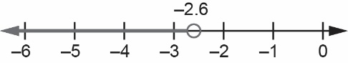
6. $9.5 -2.5a>16$
$$9.5 -2.5a+2.5a>16+2.5a$$
$9.5>16+2.5a$
$9.5 -16>16-16+2.5a$
$-6.5>2.5a$
$\frac{-6.5}{2.5}>\frac{2.5a}{2.5}$
$-2.6>a$
Choose a value less than ‒2.6: a = ‒4
L.S. = $9.5 -2.5a$ R.S.= $16$
= $9.5 -2.5(-4)$
= $19.5$
19.5 > 16, so the solution is correct.
7. Let p represent the length of pipe used, in metres.
$35-p ≥7$
$35-p+p≥7+p$
$35≥7+p$
$35-7≥7-7+p$
$28≥p$
They could have used a length of 28 m or less (but greater than 0 m).

8. Let t represent the time, in minutes, spent on social media each weekday.
$5t+127<562$
$$5t+127-127 <562-127$$
$5t<435$
$\frac{5t}{5}<\frac{435}{5}$
$t<87$
They could spend any time less than 87 min on social media each weekday.

