Number Lines
Patterns and Relations
Unit 4 Line Master 2a

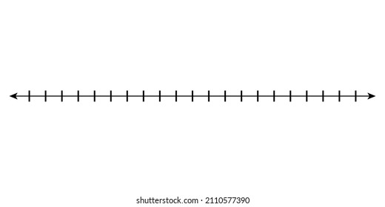

Number Lines
Patterns and Relations
Unit 4 Line Master 2b

