Ways to Solve Linear Equations
Patterns and Relations
Unit 3 Line Master 1c
Answers

Models are all sample solutions.
1. a) x = 6
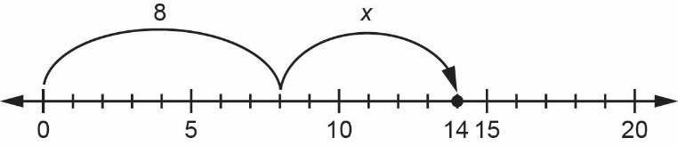

b) x = 3
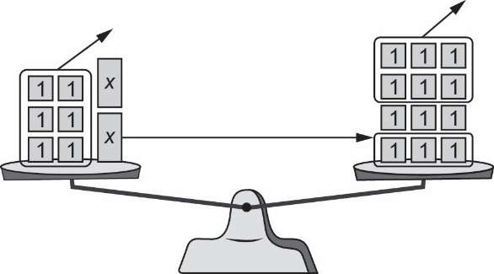

c) x = 7
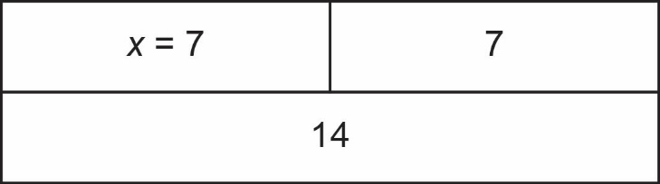

d) x = 7
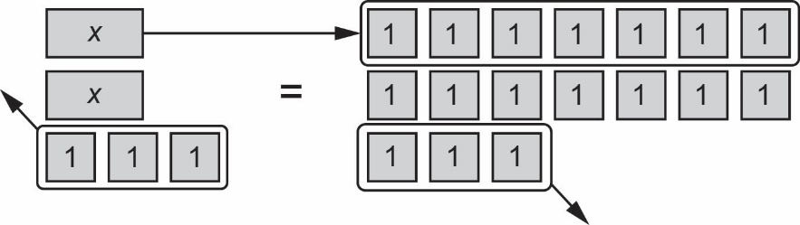

Ways to Solve Linear Equations
Patterns and Relations
Unit 3 Line Master 1d
Answers (cont’d)

2. a) For example: 3 times a number is 12. I know 3 × 4 = 12, so x = 4.
b) For example: 5 more than 2x is 11, so 2x must be 11 – 5, or 6.
Then, 2 times a number is 6. I know 2 × 3 = 6, so x = 3.
c) For example: 2 less than a number is 9. So, the number must 9 + 2, or 11: x = 11

3. a) For example: I could model the equation using algebra tiles: I would have 3 x tiles and 2 unit tiles on the left and 17 unit tiles on the right. I would take away 2 unit tiles from both sides, leaving 3 x tiles on the left and 15 unit tiles on the right. Then I would match each x tile to an equal number of unit tiles on the right, which is the same as dividing the 15 unit tiles into 3 equal groups.

b) For example: Sammy’s method always makes sure that the same operation is applied to both sides. When 2 is taken away from both sides, both sides still have the same amount. When both sides are divided by 3, each side is $\frac{1}{3}$ as big.

c) For example: Sammy can use this method with all types of numbers, whereas
it might be difficult to use some models, like algebra tiles or a pan balance, when the numbers are fractions or decimals, of when the answer is a fraction or decimal.

4. $5x-8=-35x-8+8=-3+8$
$5x=5$
x = 1

