Brightening Sun
and Decreasing Heat
Patterns and Relations
Unit 2 Line Master 6a

Brightening Sun
This model shows the brightness of the Sun for the first 3 minutes
after its release. Each square represents 1 unit of brightness.
The hexagon has a unit of brightness of 3.
1 min 2 min 3 min
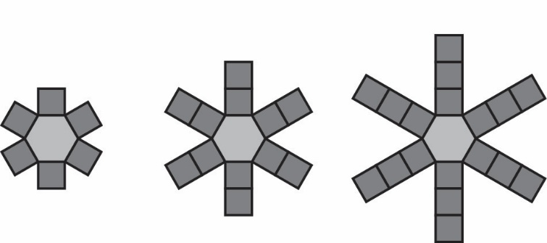
1. Complete the table.
Number of minutes since Sun was released | Number of units  of brightness
1
2
3
4
5
10

2. What is the relationship between the number of squares (units of brightness)
and the number of minutes since Sun was released?

3. Write an equation to represent the relationship.

Brightening Sun
and Decreasing Heat (cont’d)
Patterns and Relations
Unit 2 Line Master 6b

4. What represents the constant in the model?
What represents the constant in your equation?

5. Describe what the model would look like when Sun was released (at 0 min)?

6. Use your equation to determine the number of units of brightness
16 min after Sun was released.

7. How would your equation change if each term in the model represented 0.5 min instead of 1 min?

0.5 min 1 min 1.5 min
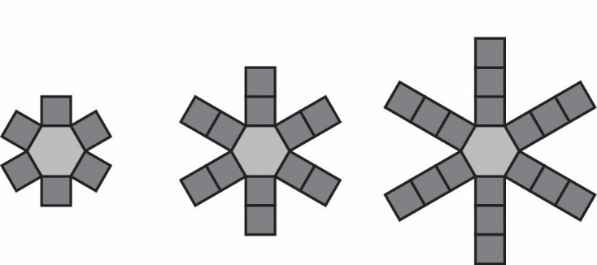

Brightening Sun
and Decreasing Heat (cont’d)
Patterns and Relations
Unit 2 Line Master 6c

Decreasing Heat
When Sun was taken, the temperature on Earth began to drop.
The average temperature on Earth is 15°C.
1. Suppose the temperature drops 3.75°C every 1.5 h.
Complete the table to show the temperature after each number of hours.
Number of hours since Sun was taken | Temperature (°C)
0 | 15
1.5
3
4.5
6
9

2. What is the relationship between the temperature and the number of hours
after Sun was taken?

3. Write an equation to represent the relationship.

4. Use your equation to predict the temperature for each number of hours
after Sun was taken.
a) 5 h

b) 24 h

5. How long would it take for the temperature to reach the freezing point, 0°C?

