Multiplying and Dividing Polynomials
Answers
Patterns and Relations
Unit 1 Line Master 6e

Part A: Multiplying Polynomials
- 2x represents the product of 2 × (x).
Model (x) × (x). Model 2 × (x).
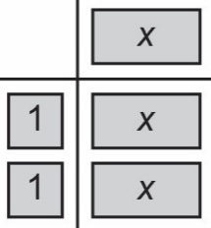
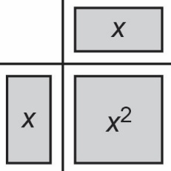

The two models are not equivalent.
So, (x) × (x) ≠ 2x.

2. a) 2x(3x + 1) = 6x² + 2x
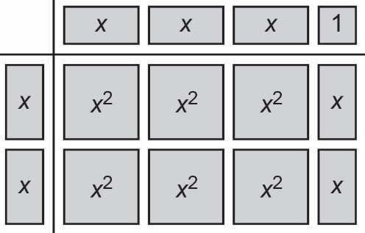
b) −3x(4x − 1) = −12x² + 3x
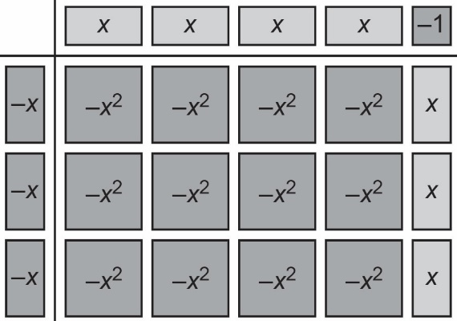

Multiplying and Dividing Polynomials
Answers (cont’d)
Patterns and Relations
Unit 1 Line Master 6f

3. a) 2(2x² − 3x + 1) = 4x² − 6x + 2
b) 4(5y² − 3y + 8) = 20y² − 12y + 32
c) −6x(−2x − 9) = 12x² + 54x

Part B: Dividing Polynomials
1. I know that when I divide a polynomial by a monomial, I can write each term of the polynomial as a division with the monomial as the denominator. For example,
(−6x² + 12x) ÷ 3x can be written as $\frac{-6x^{2}}{3x}+ \frac{12x}{3x}$.
I can then simplify the individual fractions.
I also know that when dividing like terms with different exponents, I subtract the exponents. So, x² ÷ x = x, because 2 − 1 = 1.
2. a) (8x² + 2x) ÷ (2x) = $\frac{8x^{2}}{2x}+ \frac{2x}{2x}$
= 4x + 1
b) (−6x² − 3x) ÷ (−3x) = $\frac{-6x^{2}}{-3x}+ \frac{-3x}{-3x}$
= 2x + 1
c) (−6x² − 8x) ÷ (2x) = $\frac{-6x^{2}}{2x}+ \frac{-8x}{2x}$
= ‒3x ‒ 4

Multiplying and Dividing Polynomials
Answers (cont’d)
Patterns and Relations
Unit 1 Line Master 6g

3. a) $\left(\frac{9s}{-3}\right)\left(-4s\right)$ = (‒3s)(‒4s)
= 12s²
b) The order of operations tells me that I need to simplify the expression inside the first set of brackets before multiplying by the expression in the second set of brackets. If I didn’t do this, I would have to multiply and divide larger numbers: $\frac{-36s^{2}}{-3}$. The answer would be the same because the order in which multiplication and division are performed doesn’t matter.

4. a) (14x² − 7x) ÷ 7x = $\frac{14x^{2}}{7x}- \frac{7x}{7x}$
= 2x ‒ 1
b) (‒8x² + 6x ‒ 4) ÷ 2 = $\frac{-8x^{2}}{2}+ \frac{6x}{2}- \frac{4}{2}$
= ‒4x² + 3x ‒ 2
c) $\left(\frac{4m^{2}}{-2m}\right)\left(-3m\right)$ = (‒2m)(‒3m)
= 6m²

