Midnight Madness Events
Patterns and Relations
Unit 1 Line Master 5a

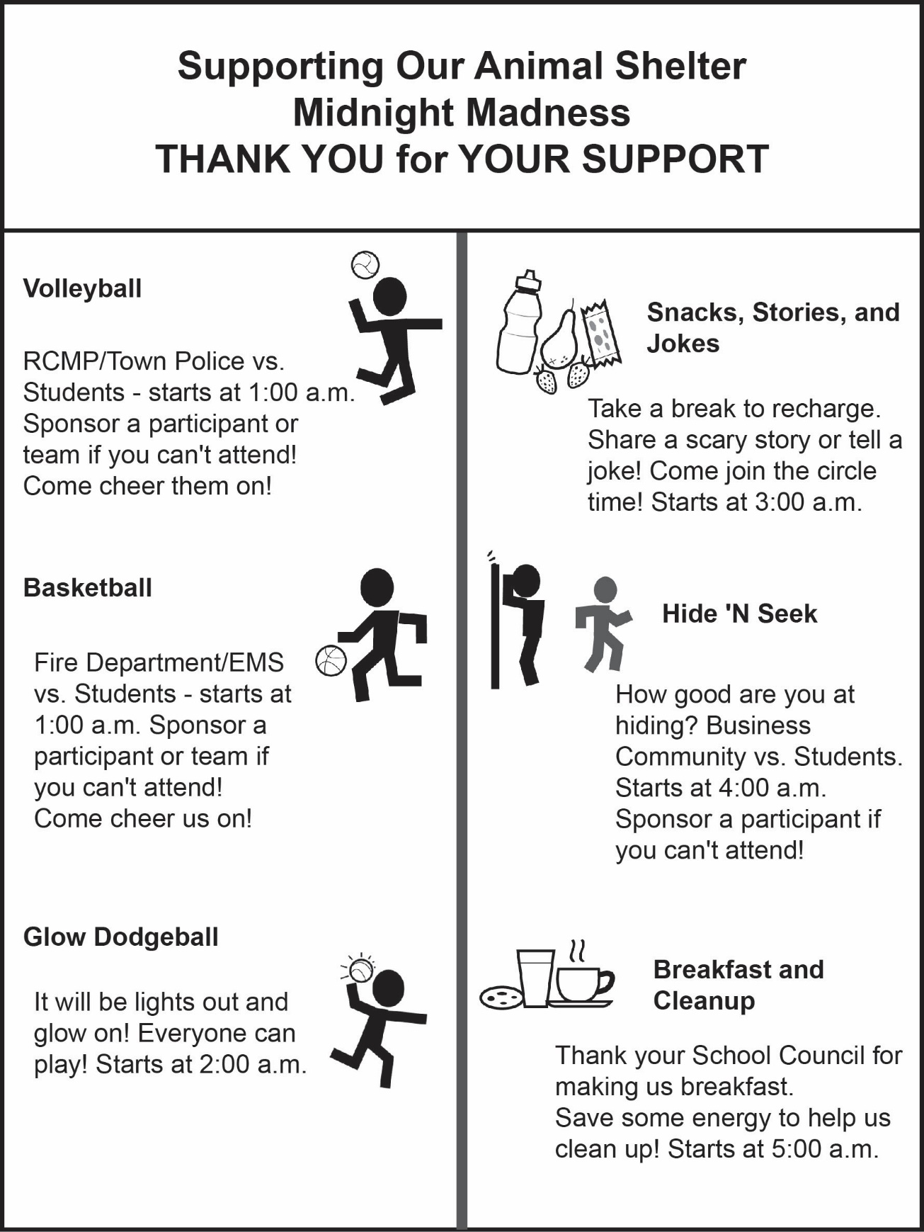

Midnight Madness Events (cont’d)
Patterns and Relations
Unit 1 Line Master 5b

