Subtracting Polynomials
Patterns and Relations
Unit 1 Line Master 3a

Use algebra tiles to help answer the questions below.

- a) Model 3x.

b) Show how you could remove 2x. Write the process symbolically.

c) Model and simplify 3x + (−2x).

d) How are addition and subtraction related?

- Rewrite each polynomial using only addition.
- x² − 6x + 3

- −4x² − 9

3. Simplify each polynomial.
- 3x² − 5x + 2x − x² − 7

- −4x² + 7x − x² − 3 + (−4x)

Subtracting Polynomials (cont’d)
Patterns and Relations
Unit 1 Line Master 3b

4. Colin modelled and simplified 5x − (−x) as shown below.
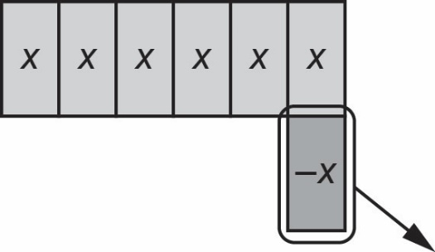

a) Why did Colin add a zero pair to the model?

b) What is the result of this subtraction?

c) How does this result relate to the statement “subtracting is the same as
adding the opposite”?

5. Sara completed the subtraction (2x + 8) − (3x − 6) by first rewriting it
as (2x + 8) + (−3x + 6).
a) Why did Sara change the terms in the second bracket to −3x + 6?

b) Sara got the answer −1x + 14. Is their answer correct?

c) Use Sara’s method to complete this subtraction.
(−4m² − 5m − 6) − (−7m² + 3m − 1)

