Subtracting Polynomials Answers
Patterns and Relations
Unit 1 Line Master 3c


1. a)

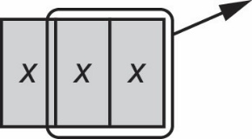
b)

3x − 2x = x

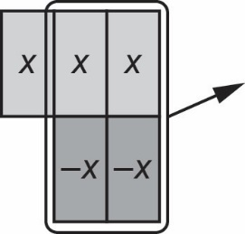
c)

3x + (−2x) = x

d) Subtracting a polynomial gives the same answer as adding the opposite polynomial.
3x − 2x = 3x + (−2x)

2. a) x² + (−6x) + 3
b) −4x² + (−9)

3. a) 2x² − 3x − 7
b) −5x² + 3x − 3

4. a) There was no −x-tile to remove. By adding a zero pair, the −x-tile can now be removed, leaving 6 x-tiles.
b) 6x
c) 5x − (−x) = 5x + (+x)
= 6x

5. a) Sara wanted to add the opposite. The opposite of 3x is −3x and the opposite
of −6 is +6.
b) Yes, Sara’s answer is correct.
c) (−4m² − 5m − 6) − (−7m² + 3m − 1) = (−4m² − 5m − 6) + (7m² − 3m + 1)
= 3m² − 8m − 5

