Close to Perfect!
Number
Unit 1 Line Master 8a

1. Cut out the square root cards.
Place each card in the bin that best estimates its square root.
2. For the four blank cards, write a number under each square root sign
so that one card fits in each bin.

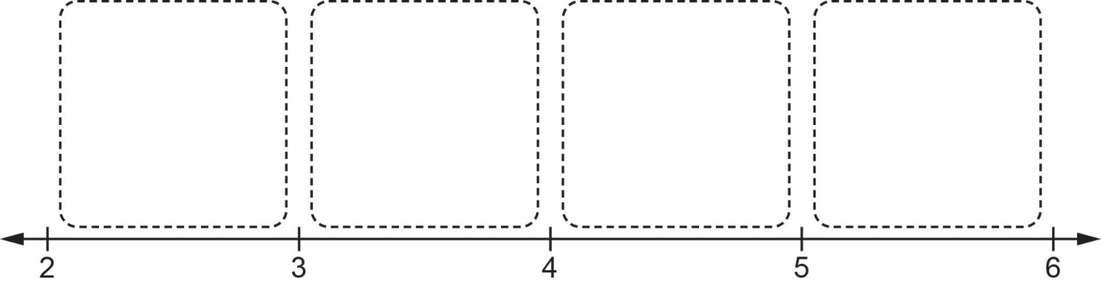

$$\sqrt{32}$$ | $$\sqrt{18}$$ | $$\sqrt{10}$$ | $$\sqrt{5}$$
$$\sqrt{7.8}$$ | $$\sqrt{31.86}$$ | $$\sqrt{23.2}$$ | $$\sqrt{11.8}$$
$$\sqrt{19\frac{1}{3}}$$ | $$\sqrt{\frac{19}{2}}$$ | $$\sqrt{\frac{23}{5}}$$ | $$\sqrt{27\frac{5}{8}}$$

Close to Perfect! (cont’d)
Number
Unit 1 Line Master 8b

3. For each square root below:
a) Estimate its value to the nearest whole number.
Explain your reasoning.
b) Estimate its value to the nearest tenth.
Explain your reasoning.
c) Check your answer using a calculator.

$\sqrt{32}$ $\sqrt{18}$ $\sqrt{23.2}$ $\sqrt{19\frac{1}{3}}$

