Investigating Perfect Square Fractions
Number
Unit 1 Line Master 5a

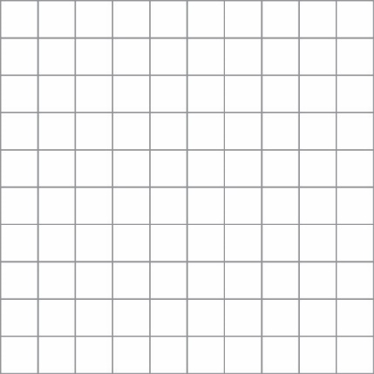
1. This grid has 100 grid squares.
a) Shade grid squares to model $\frac{81}{100}$ as a square.

b) What is the side length of the shaded square?

c) The grid has side length 10 units.
Write the side length of your shaded square as
a fraction of the side length of the grid
(e.g., with denominator 10).
d) What do you notice about the side length of the shaded part?
e) Is $\frac{81}{100}$ a perfect square? Explain.

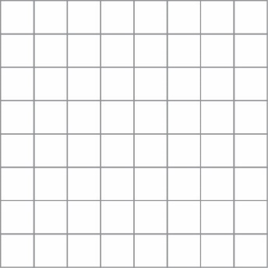
2. This grid has 64 grid squares.
a) Shade grid squares to model $\frac{36}{64}$ as a square.

b) What is the side length of the shaded square?

c) The grid has side length 8 units.
Write the side length of your shaded square as a fraction
of the side length of the grid (e.g., with denominator 8).

d) What do you notice about the side length of the shaded part?

e) Is $\frac{36}{64}$ a perfect square? Explain.
Investigating Perfect Square Fractions (cont’d)
Number
Unit 1 Line Master 5b

3. Each of these fractions is less than 1. For each fraction:
- Identify whether it is a perfect square or not. Explain or illustrate using a square.
- If the fraction is a perfect square, identify its square root. Multiply to check.
- If the fraction is not a perfect square, explain your reasoning.
a) $\frac{25}{49}$

b) $\frac{16}{36}$

c) $\frac{64}{75}$

d) $\frac{14}{25}$

4. Each of these fractions is greater than 1. For each fraction:
- Identify whether it is a perfect square or not.
- If the fraction is a perfect square, identify its square root. Multiply to check.
- If the fraction is not a perfect square, explain your reasoning.
a) $\frac{49}{16}$

b) $\frac{75}{16}$

c) $5\frac{4}{9}$

d) $3\frac{13}{36}$

