Content: Exploring the Pythagorean Theorem
Identifies hypotenuse of a right triangle  The hypotenuse is the longest side of a right triangle and is opposite the 90° angle. | Describes the Pythagorean theorem  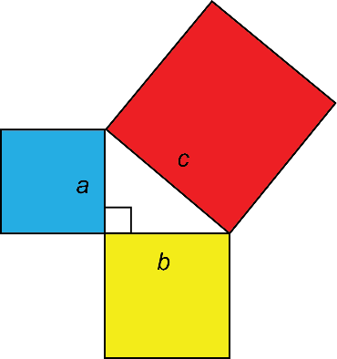  a² + b² = c²  In a right triangle, the sum of the areas of the two smaller squares equals the area of the larger square. | Uses the Pythagorean theorem to identify a right triangle  Do the lengths 3 cm, 4 cm, and 5 cm form a right triangle?  The numbers 3, 4, 5 are a Pythagorean triple. Since Pythagorean triples satisfy the Pythagorean theorem, these lengths form a right triangle.  3² + 4² = 9 + 16 = 25, which is 5² | Applies the Pythagorean theorem  to determine the length of the hypotenuse  A top of a slide is 6 m above the ground and the base of the slide is 4.5 m along the ground. How long is the slide?  The length of the slide represents the hypotenuse of a right triangle.  I can use the Pythagorean theorem.  a² + b² = c²  6² + 4.5² = c²  36 + 20.25 = c²  c² = 56.25  c = $\sqrt{56.25}$  c = 7.5  The slide is 7.5 m long.
Observations/Documentation

Competency: Representing and Connecting
Represents with concrete materials; connects areas of squares to triangle sides  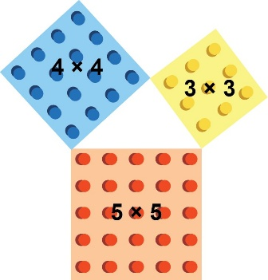  “I see that when I multiply the length of a side by itself, I get the area of the square. I also see a relationship among the areas of the squares:  9 units² + 16 units² = 25 units².” | Represents pictorially; connects patterns in areas across right triangles  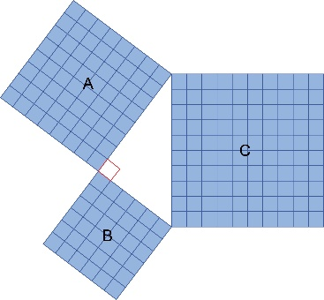  “I see that the size and orientation of the right triangle don’t matter. This relationship is always true:  Area of C = Area of A + Area of B.” | Represents in multiple ways, including algebra; connects visual, numerical, and algebraic representations  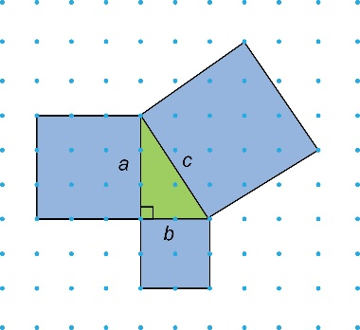  “I labelled the legs of the triangle a and b, and the hypotenuse c.  I can write the relationship as  a² + b² = c².” | Represents flexibly; connects triples and generalises patterns  “I know that the set of numbers  5, 12, 13 represents a Pythagorean triple because I can visualize a right triangle with those side lengths. I also know that 5² + 12² = 13² because both sides of the equation have a value of 169.  To generate other triples, I can multiply each number by the same factor to get another triple.  5 × 2 = 10  12 × 2 = 24  13 × 2 = 26  10, 24, 26 is also a Pythagorean triple.”
Observations/Documentation

