Content: Representing linear relations in different ways
Creates a concrete model of a linear relation and identifies the rate of change  “I created the growing sun pattern that grows by 6 units of brightness each time. The rate of change is 6.”  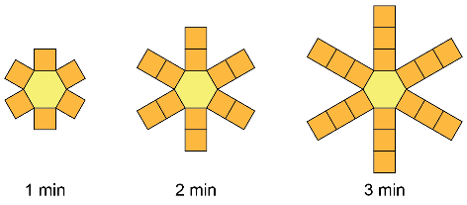 | Writes an expression or equation to represent a linear relation modelled concretely or in a table  “The initial value is 9 – 6 = 3 and the rate of change is 6. So, an equation to represent the number of units of brightness, b, after m minutes is  b = 6m + 3.” | Writes an expression or equation to represent a linear relation involving rational numbers and verifies by substitution  “If the sun increases in brightness by 6 units every half minute, then it increases by 12 units every minute.  So, the equation b = 12m + 3 represents the brightness after m minutes. I can substitute to check: 12(1) + 3 = 15.” | Writes an expression or equation (with rational numbers) to represent a problem involving a linear relation without first creating a table of values  “If the car is travelling at 85 km/h, then the rate of change is 85. The car had already driven 120 km, so the initial value is 120. I can write the equation d = 85h + 120 to represent the number of kilometres travelled, d, after h hours.”
Observations/Documentation

Competency: Communicating/Communication
Uses very limited mathematical vocabulary to express and communicate ideas  “I can see that the pattern is shrinking.” | Uses some new vocabulary to express mathematical concepts and ideas  “I see that the rate of change is positive when the pattern is increasing and negative when it is decreasing. The constant is the part that is not changing.” | Uses new vocabulary clearly when communicating answers  “The rate of change of the linear relation is positive, so when the value of the independent variable increases, so does the value of the dependent variable.” | Comfortably uses new vocabulary when discussing concepts with classmates or when playing games  “I rolled a 6. Since I want the output to be as great as possible, I will make my rate of change 6. Since the initial value will also be positive, the output of my linear relation will be at least 6.”
Observations/Documentation

