Content: Writing an Expression to Describe a Linear Pattern
Constructs a table of values to represent a linear pattern and describes the pattern in words    There are 2 more circles each time. If I know the term number, I can find the number of circles by multiplying by 2, then subtracting 1. | Writes an algebraic expression to describe a linear pattern  I let n represent the term number. Then the term value can be described as 2n – 1. | Writes an algebraic expression that matches a given set of conditions and represents it in a variety of ways  Write an expression with variable n, coefficient 3, and constant term –2.  My expression: 3n – 2  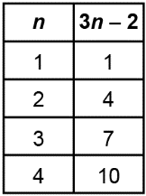  I made a pattern of square tiles to represent this relationship.  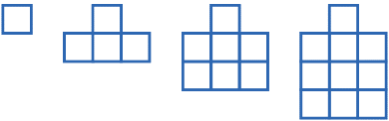 | Uses an algebraic expression or an equation to model a real-life situation  Mitchell practises for a swim meet. They swim 10 laps on Monday.  Each day for the rest of the week, they increase the number of laps they swim by 5.  The pattern is:  5, 10, 15, 20, 25, 30, 35  I can represent this with the expression 5n + 5, where n represents the day number, or with the equation T = 5n + 5, where T represents the number of laps swam.
Observations/Documentation
Next Steps  In the Moment  How could you write an algebraic expression to describe this pattern?  Encourage student to use their description of how the term value relates to the term number to help write an expression. They can choose any variable to represent the term number. | Next Steps  In the Moment  What is an example of an expression that has the variable n, a coefficient of 3, and a constant term of –2? How could you represent the expression visually?  If student struggles, show them an expression and ask them to identify the variable, coefficient, and constant term. Once they have identified each item, they can replace it with the desired letter or number. | Next Steps  In the Moment  How could you use an algebraic expression to represent a real-life situation?  Describe a simple real-life situation that involves a linear relation. Ask student to construct a table of values and write an algebraic expression and/or equation. | Next Steps  In the Moment  Challenge students to create a story when given an algebraic expression, equation, or table of values.  For the expression 3n:  Packages of flower seeds are on sale at a store for 3 for $1. If I have n dollars, I can buy 3n packages of seeds.

Competency: Representing Linear Patterns
Represent a linear pattern using concrete materials or drawings  3, 5, 7, …  “I can represent the pattern using toothpicks.”  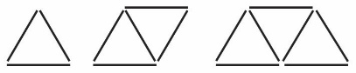 | Represents a linear pattern in a table of values  “Term 1 has 3 toothpicks, term 2 has 5, and term 3 has 7. I can see that the number of toothpicks is increasing by 2 each time, so term 4 will have 9 toothpicks.” | Represents the relationship between the term number and term value in words  “Using the table of values, I can see that to get the term value, I multiply the term number by 2, then add 1.  For example: for term 3, 3 × 2 = 6, and 6 + 1 = 7.” | Represents a linear pattern using an expression and/or equation  “I let n represent the term number. Then the term value can be described as 2n + 1.  I let V represent the term value. Then I can represent the pattern with the equation V = 2n + 1.”
  Term number | Term value
  1 | 3
  2 | 5
  3 | 7
  4 | 9
Observations/Documentation
Next Steps  In the Moment  How could you represent that pattern in a table of values?  Encourage student to record the pattern in a table of values. You might suggest they first record the term numbers below each term in the physical pattern, and the value of each term (e.g., number of toothpicks) above. | Next Steps  In the Moment  How are the term numbers and term values related?  Student may see that the term numbers are increasing by 1 each time and that the term values are increasing/decreasing by a constant amount. Encourage student to look for a relationship between the term numbers and term values. | Next Steps  In the Moment  How could you use that relationship to write an algebraic expression or equation to represent the pattern?  Prompt student to use their description of how the term value relates to the term number to help write an expression or equation. Encourage student to choose variables that will help them remember what a variable represents (e.g., n for term number and V for term value). | Next Steps  In the Moment  What real-life situation could that expression/equation represent?  Have student try to relate the expression or equation to a context from their daily life.

