Content: Multiplying and Dividing Polynomials
Multiplies polynomials concretely by determining area of rectangular region  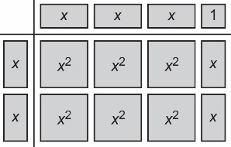  “2x(3x + 1) = 6x² + 2x” | Makes connections between multiplication and division to divide polynomials concretely  (6x² + 2x) ÷ 2x = ?  “I rewrote the division as a multiplication: ? × 2x = 6x² + 2x.  So, I modelled the dividend where the product would be, the divisor as the factor down the side, then worked backward to determine the quotient (at the top).  The quotient is 3x + 1.” | Multiplies and divides polynomial expressions symbolically  (−3x + 1)(4x) = −12x² + 4x  (−4x² + 6x) ÷ (2x)  = $\frac{-4x^{2}}{2x}+ \frac{6x}{2x}$  = −2x + 3 | Connects and applies rules of integers, exponents, and order of operations to operations with polynomials  “2[−4v(2v + 8) + 3v(−5v + 4)]  = 2[−8v² − 32v − 15v² + 12v)]  = 2[−23v² − 20v]  = −46v² − 40v”
Observations/Documentation

Competency: Connecting and Representing
Represents a polynomial with algebra tiles  “This model represents 3x + 2 because I count three x-tiles and two 1-tiles.”  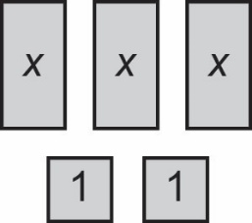 | Represents a given polynomial multiplication or division statement with algebra tiles  “I can use an algebra tile template to help me represent the division (4x² − 6x) ÷ (−2x).”  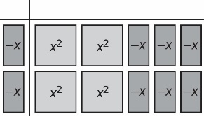 | Represents and simplifies given polynomial multiplication and division statements concretely and symbolically, and connects multiplication and division models through inverse operations  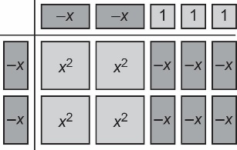  “I can check by multiplying.  (‒2x)(‒2x + 3) = 4x² ‒ 6x.” | Flexibly represents and simplifies polynomial multiplication and division statements involving multi-steps symbolically  “(5m² − 4m − 3) − 3(2m² − 6m) +  2(9m² − 3m − 7)  = 5m² − 4m − 3 − 6m² + 18m +  18m² − 6m − 14  = 17m² + 8m − 17”
Observations/Documentation

