Content: Adding and Subtracting Polynomials
Adds polynomials concretely by combining like terms and removing zero pairs  (x² ‒2x + 1) + (x² + 3x ‒ 2)  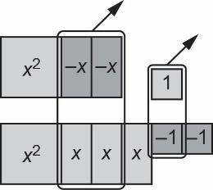  “I modelled the polynomials with tiles, and removed zero pairs, leaving 2x² + x ‒ 1.” | Adds polynomials symbolically by adding the numerical coefficients  (x² ‒2x + 1) + (x² + 3x ‒ 2)  “I added the numerical coefficients of like terms.  1x² + 1x² = 2x²  –2x + 3x = 1x 1 ‒ 2 = ‒1  So, the sum is 2x² + x ‒ 1.” | Subtracts polynomials concretely by adding zero pairs as needed  (2x² + x) ‒ (‒3x)  “To subtract ‒3x, I added 3 zero pairs of x-tiles as there were no ‒x- tiles to take away.  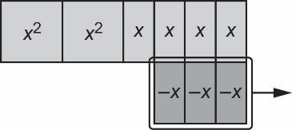  The result is 2x² + 4x.” | Flexibly adds and subtracts polynomials symbolically, thinks of subtraction as adding the opposite  “To subtract (a² − 4a + 4) − (−7a² −  2a + 5), I added the opposite:  (a² − 4a + 4) + (7a² + 2a − 5) = 8a² −  2a − 1.”
Observations/Documentation

Competency: Connecting
Connects size and shape of algebra tiles with like terms  “I know 2x² and ‒3x² are like terms because the tiles used to represent them have the same size and shape.”  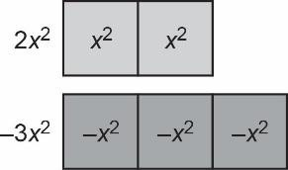 | When adding polynomials, connects like terms with different colours or with opposite signs to zero pairs  “To add (x² ‒2x + 1) and  (x² + 3x ‒ 2), I can remove pairs of tiles with the same size and shape but different colours. I am left with 2x² + x ‒ 1.” | Adds and subtracts polynomials, making connections between the operations  “I know that when subtracting polynomials, I can add the opposite. So, (5m² + 4m − 3) − (2m² − 6m + 1) is the same as (5m² + 4m − 3) + (−2m² + 6m − 1), which simplifies to 3m² + 10m − 4.” | Connects understanding of adding and subtracting polynomials to real- world situations  “Carmen walks dogs for $25 per dog and feeds cats for $5 per cat.  Carmen buys $30 worth of dog treats and cat food for $1.65 per cat.  25d + 5c − 30 − 1.65c represents the amount of money Carmen makes for walking d dogs and feeding c cats.  The expression simplifies to 25d + 3.35c − 30.”
Observations/Documentation

