Content: Exploring Polynomials
Represents polynomials concretely and pictorially and writes a polynomial expression for a given concrete or pictorial representation  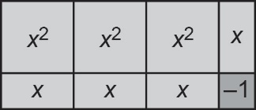  “These algebra tiles represent the polynomial 3x² + 4x ‒ 1.” | Identifies the different parts of a polynomial (variable, exponent, numerical coefficient, constant term)  “In the polynomial expression  3x² + 4x ‒ 1, 3 and 4 are numerical coefficients, x is the variable, the exponents are 2 and 1, and the constant term is ‒1.” | Identifies type of polynomial based on number of terms and names the degree of the polynomial  “The polynomial expression  3x² + 4x ‒ 1 is a trinomial because there are 3 terms. The polynomial is of degree 2 because the greatest exponent of a term is 2.” | Compares polynomials for equivalency  “3x² + 4x ‒ 1 and 4x ‒ 1 + 3x² are equivalent polynomials because they can be represented with the same algebra tiles and their graphs are the same.”
Observations/Documentation

Competency: Representing Polynomials
Represents polynomial expressions concretely or pictorially using  algebra tiles  “I used these tiles to represent  4x ‒ 1.”  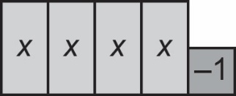 | Records the polynomial expression represented by a set of algebra tiles  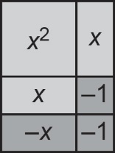  “I removed zero pairs, then wrote the expression x² + x − 2.” | Represents and simplifies polynomials concretely and pictorially, to identify equivalent polynomials  “If two polynomials can be represented by the same set of algebra tiles, then they are equivalent.” | Flexibly represents polynomials using different models to demonstrate equivalency (e.g., table of values, algebra tiles, graphing)  “The polynomials x² − 2x + 3 and  − 2x + x² + 3 have the same graph, so the polynomials are equivalent.”
Observations/Documentation

