Content: Calculating Square Roots of Perfect Squares
Determines the square root of fractions or decimals that are perfect squares using a calculator  “I can use the $\sqrt[2]{}$ button on a calculator to determine the square root of a number: $\sqrt{0.81}=0.09$.” | Determines the square root of whole numbers that are perfect squares using non-calculator strategies (e.g., using mental math)  “I know that 4 × 4 = 16, so the square root of 16 is 4.” | Determines the square root of fractions or decimals that are perfect squares using non-calculator strategies (e.g., using mental math)  “3 × 3 = 9 and 4 × 4 = 16, so the square root of $\frac{9}{16}$ is $\frac{3}{4}$ .” | Solves real-world problems by determining the square roots of rational numbers  “If the area of the field is 31.36 m², then the side length of the field is the square root of its area.”
Observations/Documentation

Competency: Representing
Represents perfect squares of whole numbers  “I can use 16 grid squares to make a square, so 16 is a perfect square.” | Represents a fraction that is a perfect square on a grid  “I can represent $\frac{81}{100}$ by outlining a 10 by 10 grid, then shading 81 grid squares to make a square.”  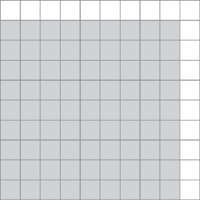 | Represents a fraction on a grid to determine whether it is a perfect square  “For $\frac{47}{64}$, I can represent the denominator as an 8-by-8 grid, but I can’t represent 47 as a square. So, $\frac{47}{64}$is not a perfect square.” | Relates fraction models to decimals  “I can think of 0.49 as $\frac{49}{100}$. I can represent the denominator as a 10-by-10 grid, then shade a 7-by-7 square to represent the numerator, 49. So, $\frac{49}{100}$ and 0.49 are perfect squares.”  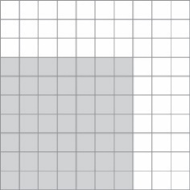
Observations/Documentation

