Investigating Perfect Squares and Square Roots
Uses exponential notation to show factors of a number  25 = 5 × 5  = 5² | Identifies a perfect square and a non-perfect square  64 = 8 × 8  = 8²  64 is a perfect square because it can be written as the product of two equal integers factors  63 = 3 × 3 × 7  = 3² × 7  63 is not a perfect square because it cannot be written as the product of two equal integer factors. There is a single prime factor of 7 leftover | Determines the square root of a perfect square  144 = 2 × 2 × 2 × 2 × 3 × 3  = 2 × 2 × 3 × 2 × 2 × 3  = 12 × 12  $\sqrt{144}$ = 12 | Estimates the square root of a non-perfect square  I know that $\sqrt{81}$ = 9 and $\sqrt{100}$ = 10, so I estimate that $\sqrt{90}$ is approximately 9.5 because 90 is about halfway between 81 and 100.  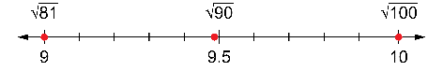
Observations/Documentation

Competency: Representing
Represents a whole number using tiles to determine whether it is a perfect square  “I can use 16 tiles to make a square, so 16 is a perfect square.”   | Represents a whole number on a grid to determine whether it is a perfect square  “I can shade 16 grid squares to make a square, so 16 is a perfect square.”  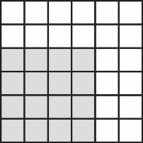 | Records all the factors of a whole number to determine whether it is a perfect square  “The factors of 16 are: 1, 2, 4, 8, 16. Since there are an odd number of factors, 16 is a perfect square.” | Represents a whole number as a product of its prime factors to determine whether it is a perfect square  “I can write 16 as a product of its prime factors: 16 = 2 × 2 × 2 × 2.  I can combine the prime factors to write 16 = 4 × 4, a product of two equal integer factors. So, 16 is a perfect square.”
Observations/Documentation

