Statistics and Probability
Unit 2 Line Master 2a
Tree Diagrams

A. Spinning orange and picking orange
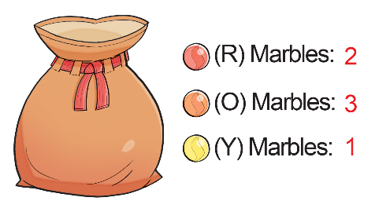
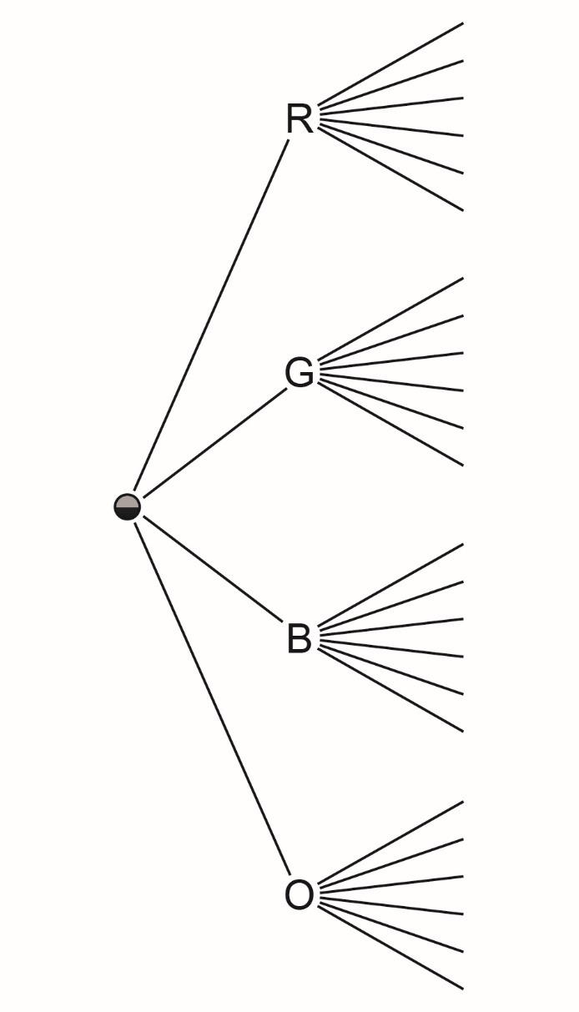

Statistics and Probability
Unit 2 Line Master 2b
Tree Diagrams (cont’d)

B. Landing tails and picking red

