Answers

Shape and Space
Unit 1 Line Master 9f

1. Volume: 331.6625 cm³; label area: 204.1 cm²;
design cost: $306.15
2. a) The jars have similar volumes. To the nearest cubic
centimetre, the volume of the first jar is 593 cm³ and
the volume of the second jar is 580 cm³.
b) The first jar; to the nearest cent, the label design cost
for the first jar is $256.22 and the label design cost for
the second jar is $296.26.
3. In the main program, I would set the pricePerSquareCM variable to 1.25 instead of 1.5.
4. Sample answer:
The first part of the subprogram collectInfo would change to
ask for the container radius
In the subprogram calculateVolume, I would delete the line that determines the radius.
I would change the subprogram calculateLabelArea,
like this:
subprogram calculateLabelArea
labelArea = 2 * pi * radius * labelHeight
display labelArea

Answers (cont’d)

Shape and Space
Unit 1 Line Master 9g

5. Sample answer:
a) I would create a new variable for the surface area
of the top, called topSA.
In the pseudocode, I would add a new subprogram
called calculateTopSA:
subprogram calculateTopSA
topSA = pi * radius * radius
display topSA
In the program, it would look like this:
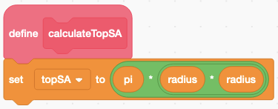
b) I would create a new variable for the cost to design the
sticker, called topStickerCost.
In the pseudocode, I would add a new subprogram
called calculateTopStickerCost:
subprogram calculateTopStickerCost
topStickerCost = pricePerSquareCM * topSA
display topStickerCost
In the program, it would look like this:
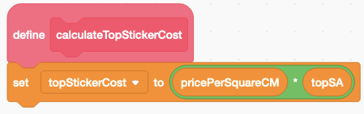
Answers (cont’d)

Shape and Space
Unit 1 Line Master 9h

Extensions:
Sample answers:
- Below the stage, I selected Show to have the sprite appear,
made the size 40, and dragged the sprite to the lower left corner of the stage.
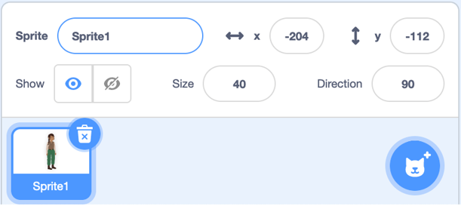
Then, at the end of the main program, I added a block that made the sprite announce what the design cost was.
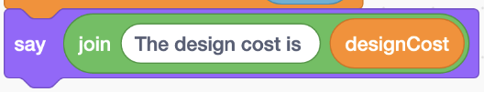

- I added a block to the end of the label design cost subprogram. The new block multiplies the designCost variable by 100, rounds it, then divides by 100.
The block looks like this:
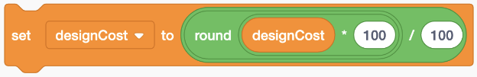

- Samples using grocery items will vary.

Answers (cont’d)

Shape and Space
Unit 1 Line Master 9i

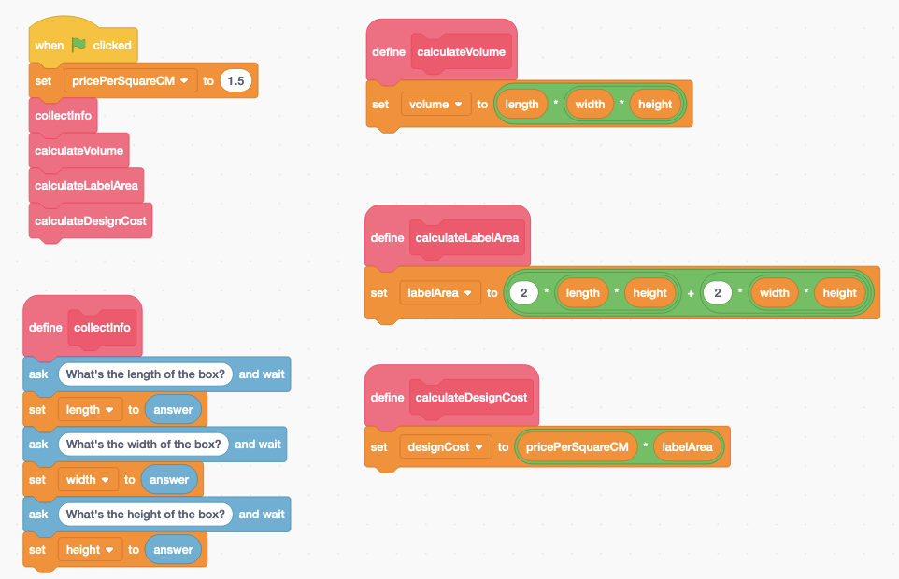
- Sample program based on modifying Yindi’s program. For this sample, an image was added to help clients visualize the box and which face will be considered the base.

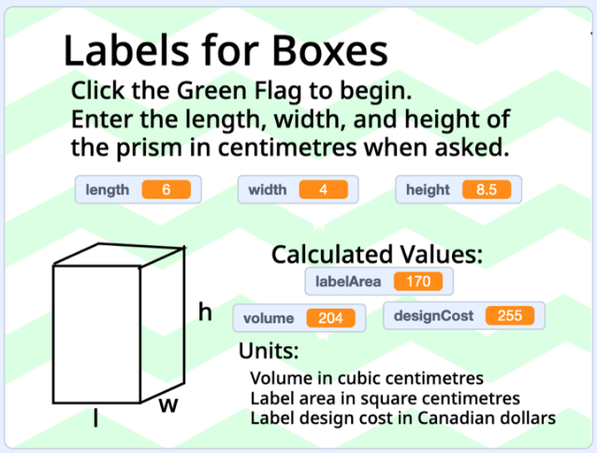
Output for box with length 6 cm, width 4 cm, and height
8.5 cm.

