Surface Area of a Triangular Prism
Shape and Space
Unit 1 Line Master 5a

Note: Each prism is drawn to scale.
Prism 1: Sketch and label the net of the right triangular prism.
Determine the surface area.
Develop a formula to determine the surface area
of the prism.

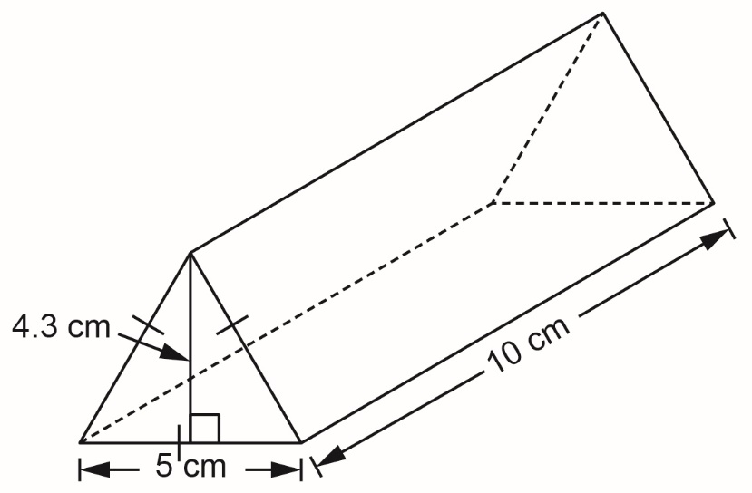

Surface Area of a Triangular Prism
(cont’d)
Shape and Space
Unit 1 Line Master 5b

Prism 2: Sketch and label the net of the triangular prism.
Determine the surface area.
Develop a formula to determine the surface area
of the prism.

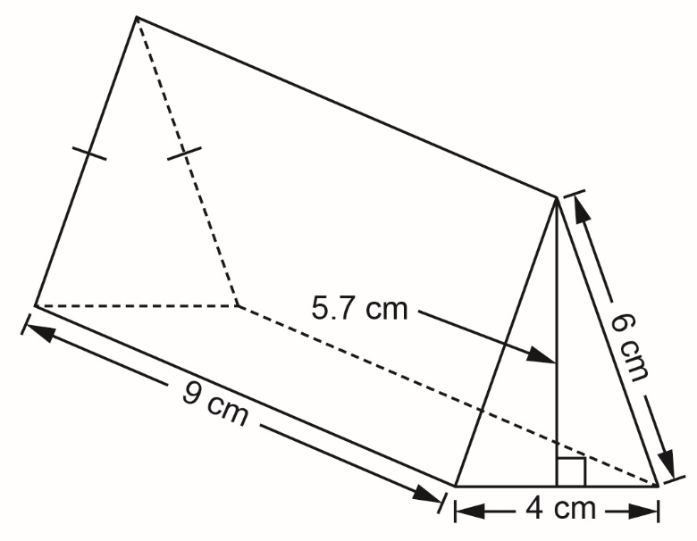

Surface Area of a Triangular Prism
(cont’d)
Shape and Space
Unit 1 Line Master 5c

Prism 3: Sketch and label the net of the triangular prism.
Determine the surface area.
Develop a formula to determine the surface area
of the prism.

