Nets of Cylinders
Shape and Space
Unit 1 Line Master 3a
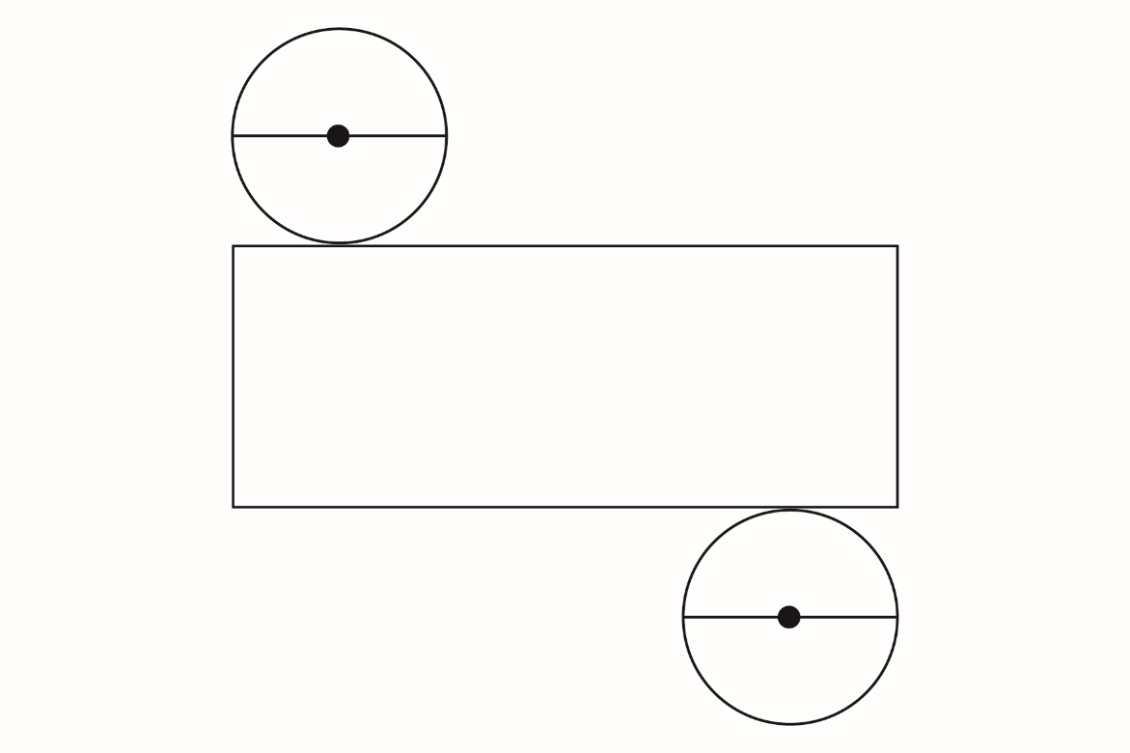

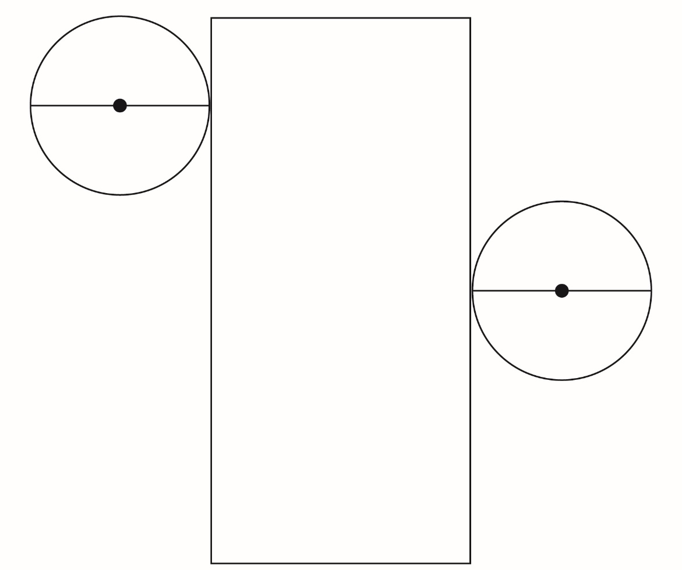
Nets of Cylinders (cont’d)
Shape and Space
Unit 1 Line Master 3b

