Nets of Prisms
Shape and Space
Unit 1 Line Master 2a

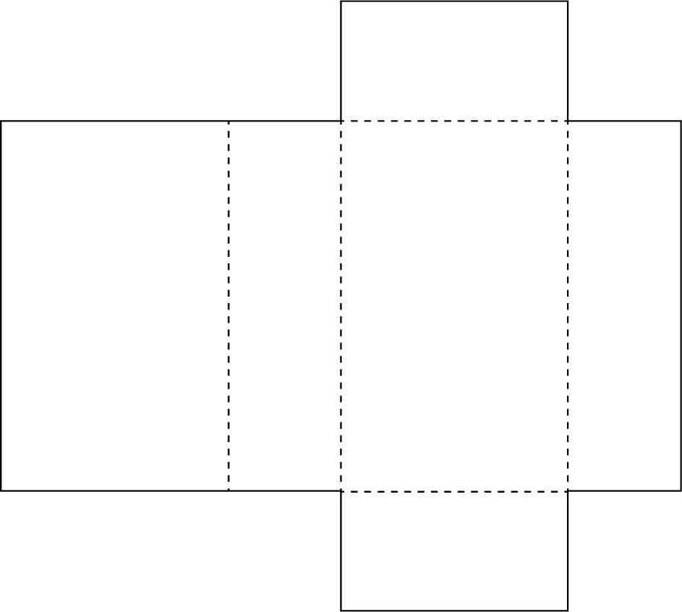

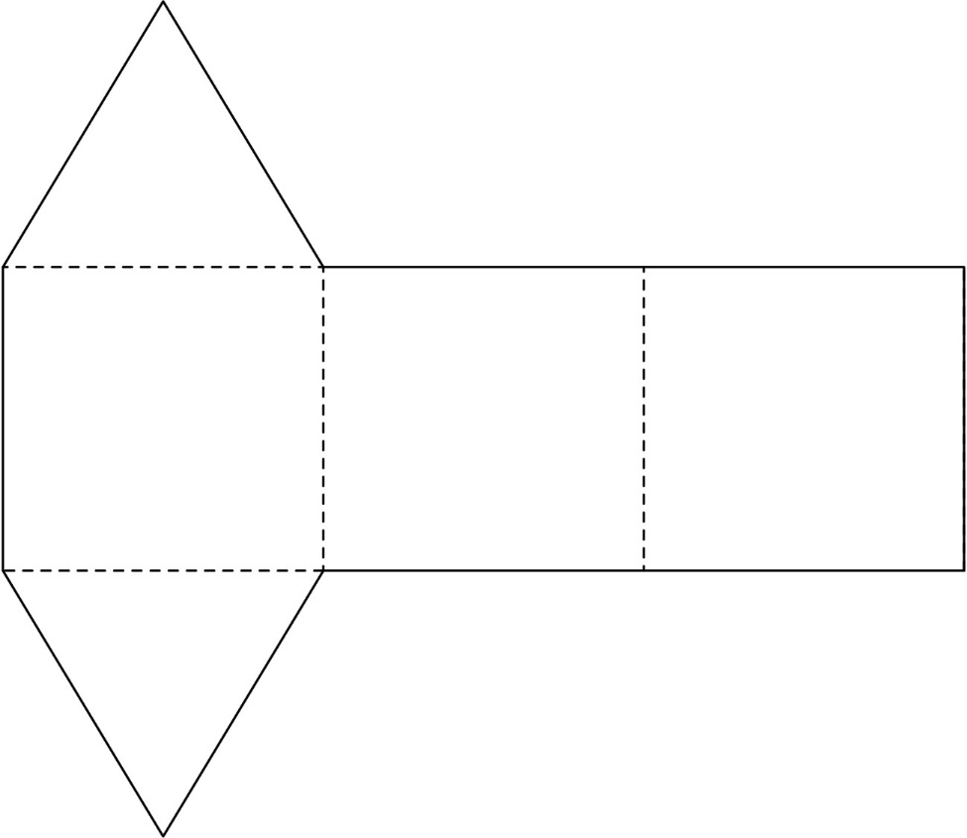
Nets of Prisms (cont’d)
Shape and Space
Unit 1 Line Master 2b

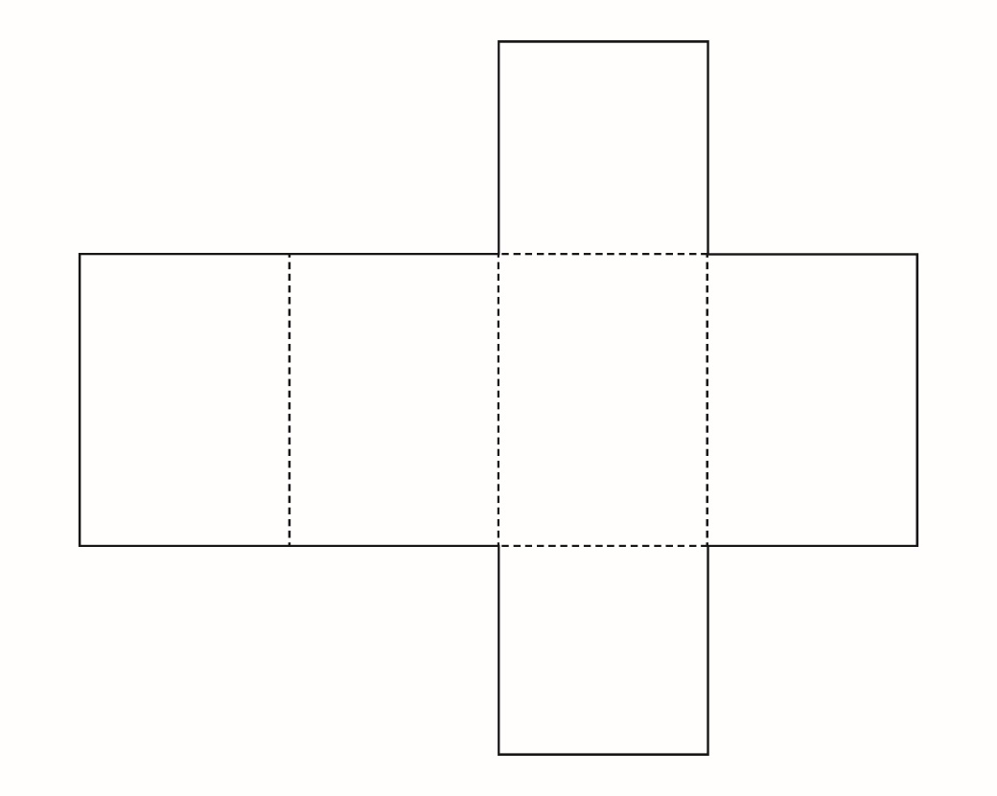

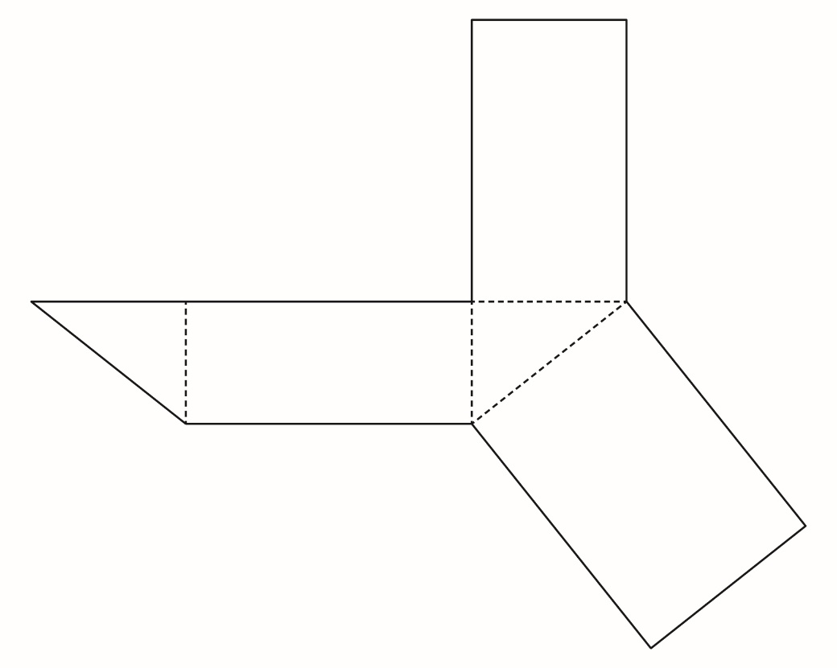

Nets of Prisms (cont’d)
Shape and Space
Unit 1 Line Master 2c

