Patterns and Relations
Unit 1 Line Master 4a
Determining Elements
in Linear Patterns

Choose two of these four patterns and answer the questions.

A.  The term value is the number of toothpicks.  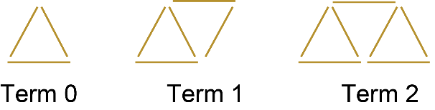 | B.  This number pattern starts with term 0  −10, −7, −4, −1, 2, …
C. | D.  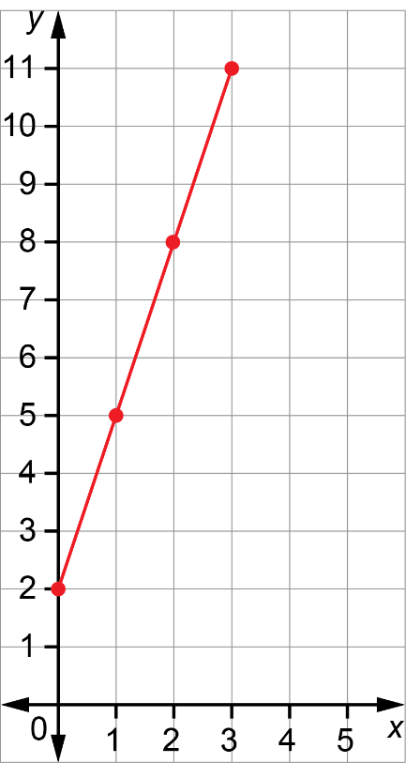
  x | y
  1 | 5
  2 | 9
  3 | 13
  4 | 17
  5 | 21

Patterning and Algebra
Unit 1 Line Master 4b
Determining Elements
in Linear Patterns (cont’d)

My first pattern is _____.

1. Write an equation to describe this pattern.
Explain how you wrote it.

2. What is the value of term 8? Show your work.

3. What is the value of term 15? Show your work.

4. What is the number of the term with a value of 41?
Explain how you know.

Patterning and Algebra
Unit 1 Line Master 4c
Determining Elements
in Linear Patterns (cont’d)

My second pattern is _____.

5. Write an equation to describe this pattern.
Explain how you wrote it.

6. What is the value of term 8? Show your work.

7. What is the value of term 15? Show your work.

8. What is the number of the term with a value of 41?
Explain how you know.

