Patterns and Relations
Unit 1 Line Master 1a

Comparing Linear Patterns

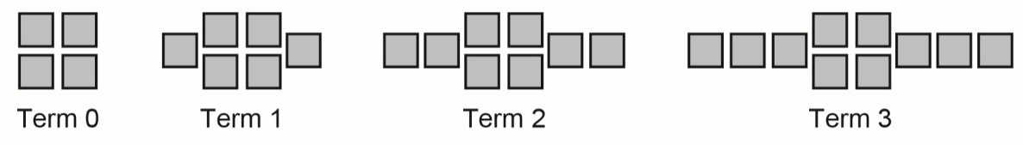
1. a) Each pattern is shown as an expression and in another form.
Complete the table of values for pattern B.
Add graphs of patterns B and C to the graph of pattern A.
B: 2x + 4

Term number, x | Term value, y
0
1
2
3

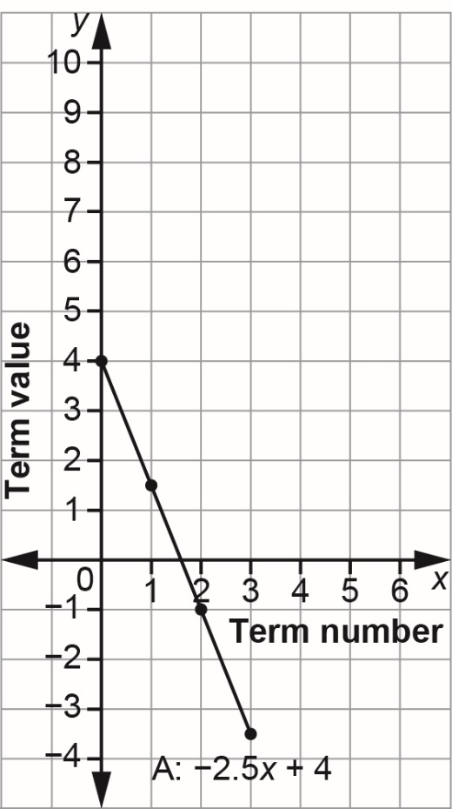

C: –x + 4
x | –x + 4
0 | 4
1 | 3
2 | 2
3 | 1

Patterns and Relations
Unit 1 Line Master 1b
Comparing Linear Patterns (cont’d)

b) How do the expressions compare?
How do the graphs compare?

2. a) Each expression represents a pattern.
For each pattern, complete the table.
A: –2x B: –2x + 2
x | –2x
0
1
2
3
x | –2x + 2
0
1
2
3

C: –2x + 4
x | –2x + 4
0
1
2
3

Patterns and Relations
Unit 1 Line Master 1c
Comparing Linear Patterns (cont’d)

b) Graph each pattern on the grid below.
You can join each set of points with a line.
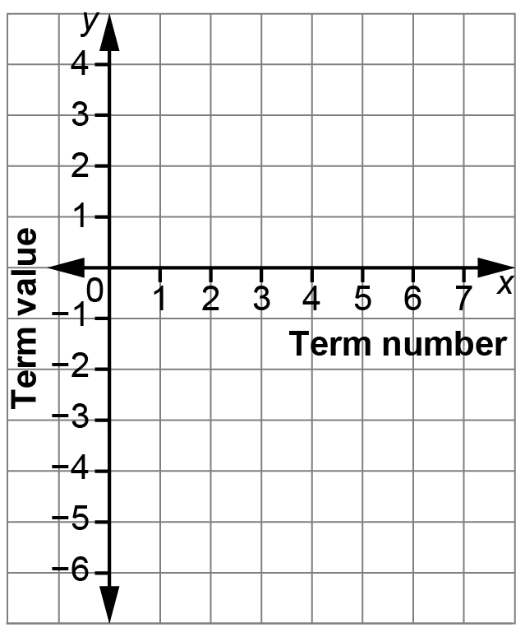

c) How do the expressions compare?
How do the lines on the graph compare?

