Number
Unit 2 Line Master 1a
Fractions Action!
Gameboard

$\frac{2}{5}$ | $\frac{4}{6}$ | $\frac{2}{3}$ | 1$\frac{1}{5}$ | $\frac{8}{3}$
1$\frac{2}{7}$ | $\frac{5}{8}$ | 2$\frac{1}{5}$ | $\frac{2}{6}$ | $\frac{6}{8}$
2$\frac{1}{8}$ | 1$\frac{1}{4}$ | FREE | $\frac{6}{15}$ | $\frac{5}{6}$
$\frac{9}{7}$ | $\frac{3}{4}$ | $\frac{1}{6}$ | $\frac{4}{10}$ | $\frac{2}{12}$
$\frac{1}{3}$ | $\frac{7}{8}$ | $\frac{6}{9}$ | $\frac{17}{8}$ | $\frac{5}{4}$
Fractions Action! (cont’d)
Game Cards

Number
Unit 2 Line Master 1b

$\frac{3}{6}$+ $\frac{2}{6}$ | Alexa mixes $\frac{2}{9}$of lemonade with $\frac{4}{9}$of water. How much liquid do they have altogether? | 2$\frac{2}{8}$– 1$\frac{3}{8}$
Gerome has a full tray of brownies. Gerome and a friend both ate $\frac{1}{6}$of the brownies. How much is left? | $\frac{1}{5}$+ $\frac{1}{5}$ | Aleshia needs $\frac{7}{5}$of soil and $\frac{4}{5}$of fertilizer for their garden. How much planting mixture will they have in total?
3 – $\frac{7}{8}$ | For one recipe, Lenor needs 1 cup of flour. For another, they needs $\frac{2}{3}$of a cup of flour. What’s the difference in flour needed? | $\frac{2}{3}$+ $\frac{2}{3}$+ $\frac{2}{3}$+ $\frac{2}{3}$
Jabar walked $\frac{5}{7}$of a kilometre and then $\frac{4}{7}$ of a kilometre to the library. How many kilometres did they walk altogether? | 1$\frac{3}{6}$– $\frac{7}{6}$ |   Orange juice comes in 2 L-bottles. You use $\frac{3}{4}$L of juice for a smoothie. How much juice is left?

Fractions Action! (cont’d)
Game Cards

Number
Unit 2 Line Master 1c

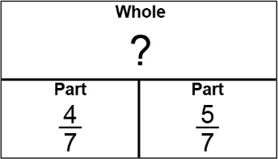 | 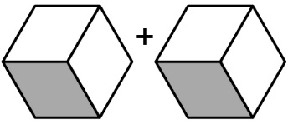 | 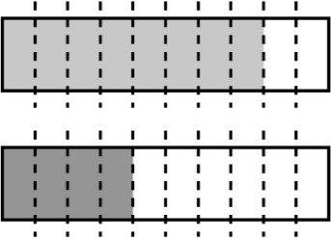
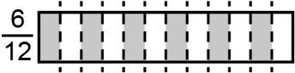 | 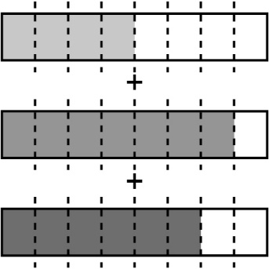 | 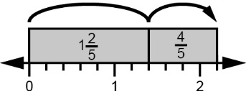
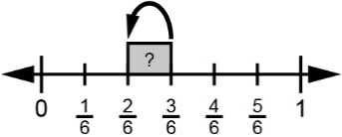 | 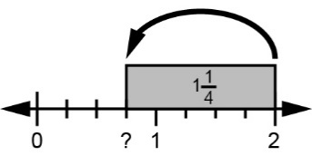 | 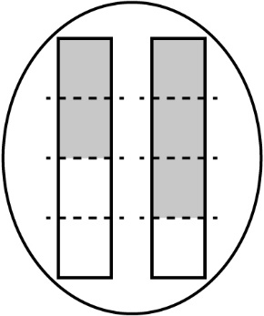
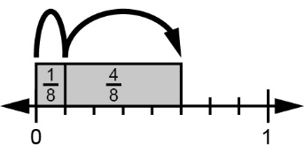 | 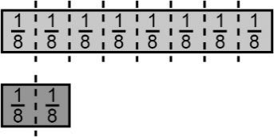 | 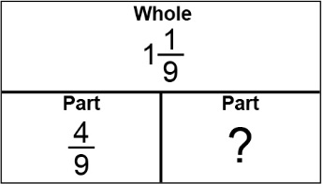

Fractions Action! (cont’d)
Gameboard

Number
Unit 2 Line Master 1d

$\frac{1}{6}$ | $\frac{2}{5}$ | $\frac{6}{9}$
$\frac{2}{3}$ | FREE | $\frac{2}{6}$
$\frac{1}{3}$ | $\frac{4}{10}$ | $\frac{5}{6}$

