Exploring Nets of Prisms and Cylinders
Understands that a 3-D object can be created by folding different nets  A net of a square has 6 congruent faces that I can visualize folding into a cube. For example:  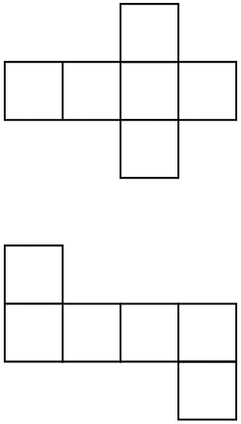 | Draws nets of rectangular and triangular prisms and cylinders  Draw a net of the rectangular prism.  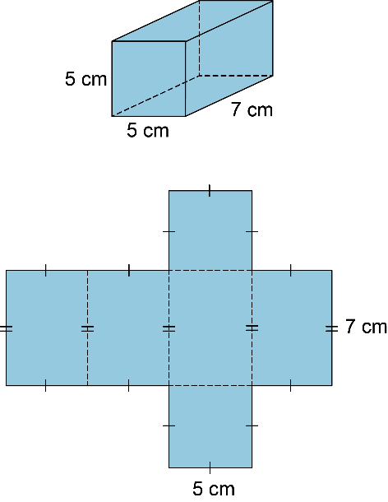 | Uses nets or folds nets to create  3-D objects  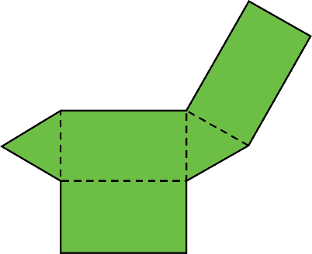  This net has 2 congruent equilateral triangles and 3 congruent rectangles.  It is a net of a triangular prism.  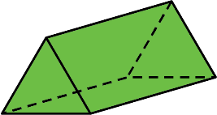 | Predicts the 3-D object formed  by a net  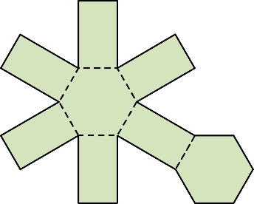  This diagram has 2 congruent regular hexagons and 6 congruent rectangles.  When it is folded, congruent sides join to form edges. The diagram is a net of a hexagonal prism.
Observations/Documentation

