Dividing Fractions
Divides a whole number by  a fraction or vice versa  $\frac{3}{4}$÷ 3  “I know that $\frac{3}{4}$ is made up of  3 one-fourth pieces.  So, when I divide by 3, I get $\frac{1}{4}$.  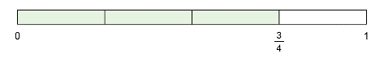  $\frac{3}{4}$÷ 3 = $\frac{1}{4}$ | Divides a fraction by another fraction, without needing to partition a ‘left-over’ portion  $\frac{3}{2}$÷ $\frac{3}{4}$  “I want to know how many  three-fourths are in 3 halves.  I can start by drawing a number line,  partitioning it in fourths, marking $\frac{3}{2}$  and making hops of $\frac{3}{4}$ until I get  there.  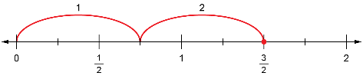  It takes 2 hops, so $\frac{3}{2}$÷ $\frac{3}{4}$= 2.” | Divides a fraction by another fraction, with partitioning of a ‘left-over’ portion  $\frac{2}{3}$÷ $\frac{1}{2}$  “I drew a number line from 0 to 1 and  marked $\frac{2}{3}$on it. I also added markings  for sixths because I know that $\frac{1}{2}$is the  same as $\frac{3}{6}$and $\frac{2}{3}$is the same as $\frac{4}{6}$.  I made hops that were $\frac{1}{2}$unit long.  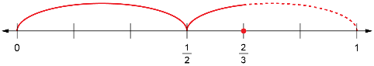  From my model, I can see that it  takes 1$\frac{1}{3}$ hops to get to $\frac{2}{3}$,  so $\frac{2}{3}$÷ $\frac{1}{2}$= 1$\frac{1}{3}$.” | Represents and solves problems that involve fraction division  Blake knows that it takes $\frac{1}{12}$of a jug to fill a glass with juice.  The juice jug is $\frac{2}{3}$full.  How many glasses can Blake fill?  “I drew a jug, showed the juice and the amount for each glass, and counted the number of glasses.  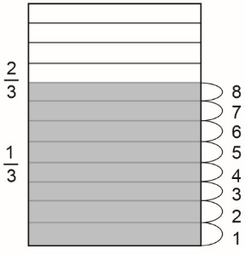  From my drawing, Blake can fill  8 glasses.”
Observations/Documentation

