Multiplying Fractions
Multiplies a fraction by a whole number  3 × $\frac{3}{4}$  “I can think of this as 3 hops of $\frac{3}{4}$  on a fraction number line.  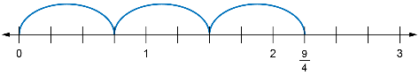  From the diagram, 3 × $\frac{3}{4}$= $\frac{9}{4}$.” | Multiplies a whole number by  a fraction  $\frac{3}{4}$ × 3  “I want to find three-fourths of 3.  I can start by drawing 3, dividing it into 4 equal parts, then shading 3  of these parts.  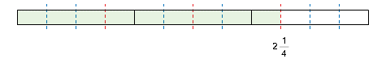  From the diagram, $\frac{3}{4}$ × 3 = 2$\frac{1}{4}$, which  is the same as 3 × $\frac{3}{4}$.” | Multiplies a fraction by a fraction  $\frac{3}{5}$ × $\frac{1}{2}$  “I drew a rectangle and shaded $\frac{1}{2}$  of it. Then drew a pattern of dots  on $\frac{3}{5}$ of the region I shaded.  In my diagram, there are 10 equal regions and 3 of them are shaded  and dotted. So, $\frac{3}{5}$ × $\frac{1}{2}$= $\frac{3}{10}$.”  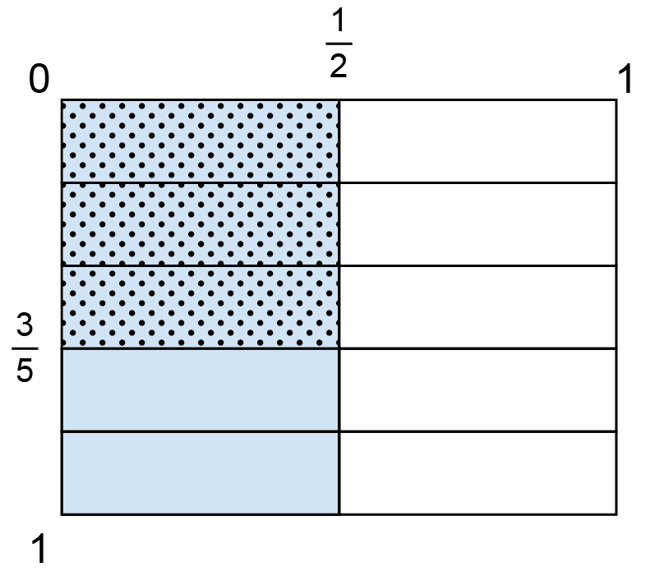 | Represents and solves problems that involve fraction multiplication  Sam had a milk jug that was $\frac{3}{4}$ full.  After filling several glasses,  Sam noticed that they had used half of the milk that was in the jug.  What fraction of a jug was left?  “I divided a rectangle into 4 equal parts and shaded $\frac{3}{4}$of it. I then drew a line to mark $\frac{1}{2}$of $\frac{3}{4}$. This line sliced the middle $\frac{1}{4}$in half. I know that half of $\frac{1}{4}$ is $\frac{1}{8}$, so I marked the rest of the eighths using a different shading.  The jug is $\frac{3}{8}$ full.”  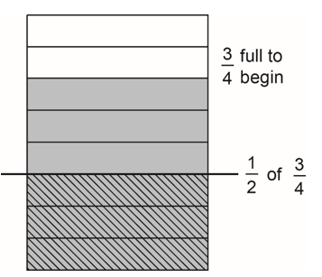

Observations/Documentation

