Multiplication and Division with Unit Fractions
Writes an equation to represent a multiplication or division situation  .  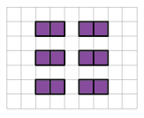  “I can represent this situation using a multiplication and a division equation.”  12 × $\frac{1}{2}$ = 6; 6 ÷ $\frac{1}{2}$ = 12 | Models situations involving a whole partitioned into unit fractions in many ways  3 ÷ $\frac{1}{3}$ = ?  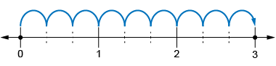  “I used a number line from 0 to 3, partitioned each whole into thirds, then counted the thirds: 1 one-third, 2 one-thirds, 3 one-thirds, …,  8 one-thirds, 9 one-thirds.  3 ÷ $\frac{1}{3}$ = 9.” | Symbolically multiplies and divides with unit fractions  7 ÷ $\frac{1}{4}$ = ?  “There are four-fourths  in 1 whole, so there will be  7 × 4-fourths, or 28-fourths  in 7 wholes.  7 ÷ $\frac{1}{4}$ = 28” | Solves multiplication and division problems flexibly, using a variety of strategies  Ha-jun hikes $\frac{1}{2}$ mile every day. How long will it be before Ha-jun has hiked 18 miles?  18 ÷ $\frac{1}{2}$ = ?  “If Ha-jun hikes $\frac{1}{2}$ mile in one day, they will hike 1 mile in 2 days.  So, Ha-jun will hike 18 miles in  18 × 2 = 36 days.”
Observations/Documentation

