Addition and Subtraction of Fractions with Unlike Denominators
Concretely solves problems.  $\frac{1}{3}$ + $\frac{5}{6}$ = ?  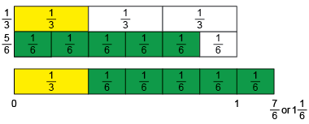  “I used fraction strips. I can see that $\frac{1}{3}$ = $\frac{2}{6}$ and that $\frac{1}{3}$ + $\frac{5}{6}$ = $\frac{7}{6}$, or 1$\frac{1}{6}$.” | Models pictorially to solve problems.  $\frac{7}{8}$ – $\frac{3}{4}$ = ?  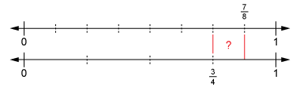  “I used a double number line. I modelled $\frac{7}{8}$ on the top line and $\frac{3}{4}$ on the bottom line, then found the difference. From the double number lines, I see the difference is $\frac{1}{8}$.” | Uses equivalent fractions to symbolically solve problems.  $\frac{1}{6}$ + $\frac{1}{3}$ + $\frac{1}{2}$ = ?  “I wrote equivalent fractions  with denominator 6.  $\frac{1}{3}$ = $\frac{2}{6}$ and $\frac{1}{2}$ = $\frac{3}{6}$  $\frac{1}{6}$ + $\frac{1}{3}$ + $\frac{1}{2}$ = $\frac{1}{6}$ + $\frac{2}{6}$ + $\frac{3}{6}$ = $\frac{6}{6}$,  or 1 whole.” | Fluently and flexibly solves problems.  $\frac{13}{4}$ - $\frac{23}{8}$ = ?  “I know that $\frac{13}{4}$ = $\frac{26}{8}$, so I counted on, in eighths, from $\frac{23}{8}$ to $\frac{26}{8}$.  I counted on $\frac{3}{8}$.”
Observations/Documentation

