Unit Rates
Understands what a unit rate is  A unit rate is a ratio between two quantities of different units, where the value of the second quantity is 1 (e.g., if 5 pens cost $10, the unit rate is $2/pen) | Uses a unit rate to create equivalent rates.  The unit rate is $2/pen.  How much will 4 pens cost?  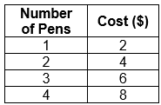  “4 pens will cost $8.” | Writes a rate as a unit rate.  I divide to write a rate as a unit rate.  For example:  100 km in 2 h is 50 km/h.” | Flexibly solves problems involving unit rates.  Which is the better deal?  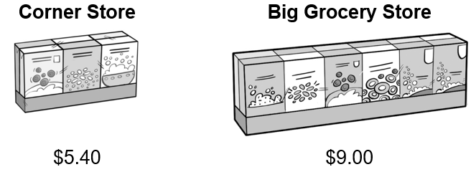  “At the corner store,  1 box is $5.40 ÷ 6 = $0.90.  At the grocery store,  1 box is $9.00 ÷ 12 = $0.75.  The grocery store has  the better deal.”
Observations/Documentation

