Whole-Number Rates
Represents and records rates symbolically  It takes 6 apples to make an apple pie. How many apples are needed to make 9 pies?  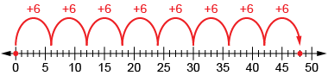  “I used a number line to show how the number of apples increases as the number of pies increases.” | Represents and creates equivalent rates  Alex runs 500 m in 2 min.  How far could Alex run in 10 min?  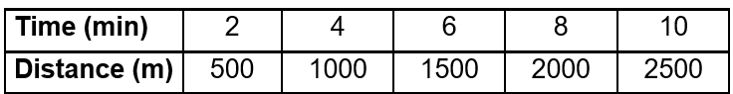  “I used a ratio table. It makes it easy to make comparisons and to solve the problem. Alex could 2500 m  in 10 min.” | Represents and creates in-between rates  Alex runs 500 m in 2 min.  How far could Alex run in 7 minutes?  “7 is halfway between 6 and 8,  so I found the number  halfway between 1500 and 2000: 1750. Alex could run 1750 m.  in 7 min.” | Flexibly solves problems involving rates  Shila cuts lawns in the neighborhood and charges $7/hour. If Shila works for 6 hours each week, how many hours will Shila need to work to make $168?    “I know that Shila makes $42 a week (7 × 6 = 42). From the ratio table, Shila will make $168 dollars  after 24 hours of work.”
Observations/Documentation

