Exploring Ratios
Identifies part-to-part and  part-to-whole two-term ratios, and writes part-to-whole ratios as fractions    red stars to blue stars = 5:3  blue stars to red stars = 3:5  red stars to all stars = 5:8; as a fraction: $\frac{5}{8}$  blue stars to all stars = 3:8; as a fraction: $\frac{3}{8}$ | Identifies part-to-part and  part-to-whole three-term ratios    red to blue to green = 5:3:7  blue stars to all stars = 3:15 | Uses a ratio table to write  equivalent ratios  Multiply each term in the ratio by the same number.  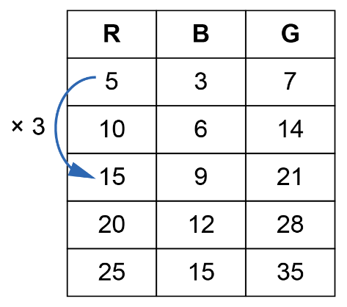 | Chooses a strategy to solve  a ratio problem  In one game, Macey saved 20 out of 30 shots on goal.  In another game, Macey faced 36 shots. They saved shots in the same ratio as the previous game.  How many shots did Macey save?  Write an equivalent ratio.  20:30 = 2:3  Use a ratio table:  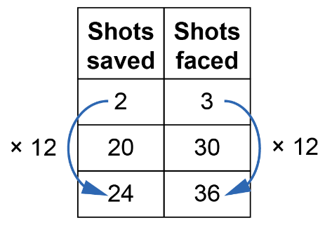  Macey saved 24 shots.
Observations/Documentation

