Introducing Ratios
  Represents and records ratios symbolically.  “The ratio of lemons to limes is 3:4. The ratio of limes to lemons is 4:3.  The ratio of lemons to all fruit is 3:7 or $\frac{3}{7}$. The ratio of limes to all fruit is 4:7 or $\frac{4}{7}$.” | Represents and creates equivalent ratios.  Is 2:3 equivalent to 8:12?  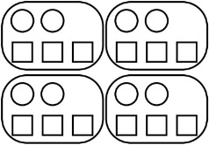  “I built a 2 to 3 ratio with circles and squares. I repeated the pattern until I had 8 circles. I counted to see that I had 12 squares, so the ratios are equivalent.”  “Or I can multiply each term in the first ratio by 4 to get the corresponding term in the second ratio, so the ratios are equivalent.” | Represents and creates in-between ratios.  A recipe calls for milk and flour in the ratio 3:2. If you use 5 cups of flour, how many cups of milk do you use?  “I multiplied the number of cups of milk and flour by 2 and by 3 to get 6 cups of milk and 4 cups of flour, and then 9 cups of milk and 6 cups of flour. Since 5 is halfway  between 4 and 6, the number of cups of milk is halfway between  6 and 9, or 7$\frac{1}{2}$.”  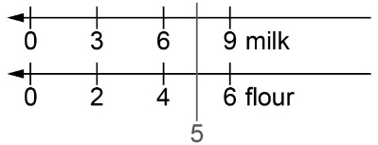  “7 is halfway between 6 and 8, so I find the number halfway between 54 and 72, which is $63.00.” | Flexibly solves problems involving ratios.  The ratio of dogs to cats in the animal shelter is 8:12. Show the comparison using percents.  “The whole is 8 + 12 = 20.  Since percent is “out of 100”,  I multiply each term in the ratio by 5 because 5 × 20 = 100.  8 × 5:12 × 5, or 40:60  40% of the animals are dogs and 60% are cats.”
Observations/Documentation

