Determining the Probability of Three Independent Events
Identifies the sample space for two independent events      The sample space is:  1, H; 2, H; 3, H; 4, H; 1, T; 2, T;  3, T; 4, T | Determines the probability of two independent events using the sample space  The theoretical probability of 2, H is:  $\frac{1}{8}$, or 0.125, or 12.5% | Determines the probability of two independent events using multiplication  The probability of rolling 2 is $\frac{1}{4}$.  The probability of tossing H is $\frac{1}{2}$.  So, the probability of the event  2, H is:  $\frac{1}{4}$× $\frac{1}{2}$= $\frac{1}{8}$ | Determines the probability of three independent events  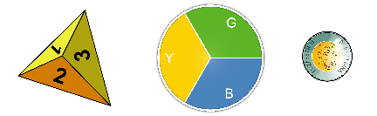  The probability of the event:  rolling 2, tossing tails, and landing on green is:  $\frac{1}{4}$× $\frac{1}{3}$ × $\frac{1}{2}$= $\frac{1}{24}$
Observations/Documentation

