Presenting Data Graphically
Compares the information from different graphs for the same  data set  Bar graph  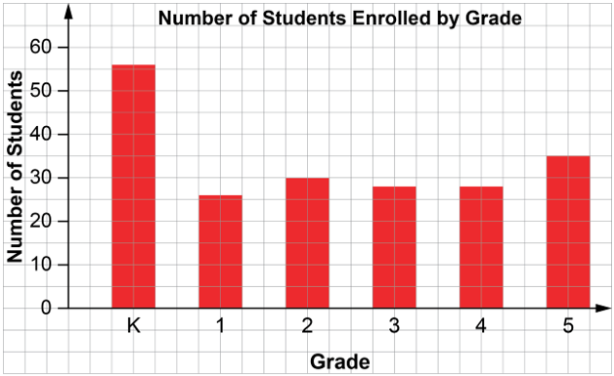  The data for the bar graph are shown as percents in this circle graph.  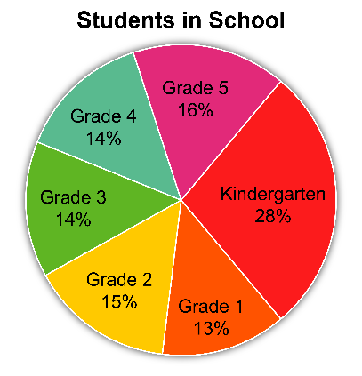  If I want to know how many students are in each grade, I would use the bar graph.  If I wanted to compare the sizes of the classes, I would use the circle graph and compare the sectors. | Uses the given data to decide on the type of graph to draw, and justifies the choice  I created a double bar graph to show the favourite streaming apps for students and teachers. Because two sets of data are being compared, a double bar graph is appropriate. It makes it easy to compare the categories.  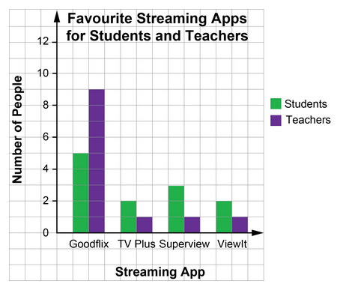 | Asks and answers questions about  a graph  Question: What do you know about the favourite streaming app of students and teachers?  Answer:  Goodflix was the favourite streaming app of both students and teachers. Almost all teachers (9 out of 12) chose Goodflix, while only 5 out of 12 students chose it. | Suggests an alternative graph  to display a given data set  For the favourite streaming apps data, two circle graphs could also be drawn, one for the students’ data and one for the teachers’ data. For each circle graph, each data value can be written as a percent of the whole.

Observations/Documentation

