Exploring Circle Graphs
Understands that a circle graph represents data that are parts of one whole  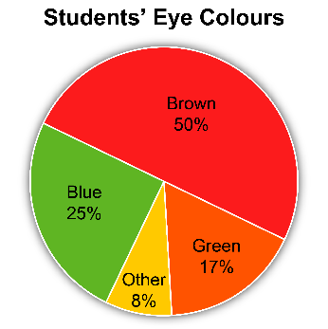  The sum of the percents is 100. This represents all the students who were surveyed. | Calculates a percent of a number  Determine 15% of 200.  “I know 1% of 200 is 2.  So, 15% of 200 = 15 × (1% of 200)  = 15 × 2  = 30” | Interprets a circle graph to answer questions  120 students were surveyed.  The number of students with blue eyes is:  25% of 120  = 0.25 × 120  = 30  30 students have blue eyes. | Uses interpretation of a circle graph to draw conclusions  “25% of students have blue eyes.  The percent of students who have green or “other” eye colours is 8% + 17% = 25%. So, the same number of students have blue eyes as have green or other.”
Observations/Documentation

