Answers
Answers
Patterns and Relations
Unit 1 Line Master 3e

1. a) Each expression represents a linear pattern.
For each pattern, complete the table of values.
A: 2x + 2 B: 3x + 2
x | 2x + 2
0 | 2
1 | 4
2 | 6
3 | 8
x | 3x + 2
0 | 2
1 | 5
2 | 8
3 | 11

C: 4x + 2
x | 4x + 2
0 | 2
1 | 6
2 | 10
3 | 14

Answers (cont’d)
Answers
Patterns and Relations
Unit 1 Line Master 3f

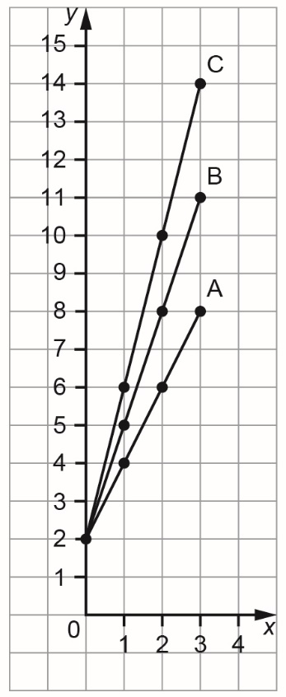
b) Graph each pattern on the grid
provided. Join each set of points
with a line.

c) How do the expressions compare?
How do the lines on the graph
compare?
The expressions all contain + 2,
but the number in front of x differs.
Each graph starts at the point
(0, 2) and the points move up
as you move right.
The + 2 tells you the initial value.
The steepness of each line
is different.
Pattern C has the steepest line.
For A: every time x increases
by 1, y increases by 2.
For B: every time x increases
by 1, y increases by 3.
For C: every time x increases
by 1, y increases by 4.
The number in front of x tells you
the constant change.

Answers (cont’d)
Answers
Patterns and Relations
Unit 1 Line Master 3g

2. a) Each expression represents a linear pattern.
For each pattern, complete the table of values.
A: 3x + 1 B: 3x + 3
x | 3x + 1
0 | 1
1 | 4
2 | 7
3 | 10
x | 3x + 3
0 | 3
1 | 6
2 | 9
3 | 12

C: 3x + 5
x | 3x + 5
0 | 5
1 | 8
2 | 11
3 | 14

Answers (cont’d)
Answers
Patterns and Relations
Unit 1 Line Master 3h

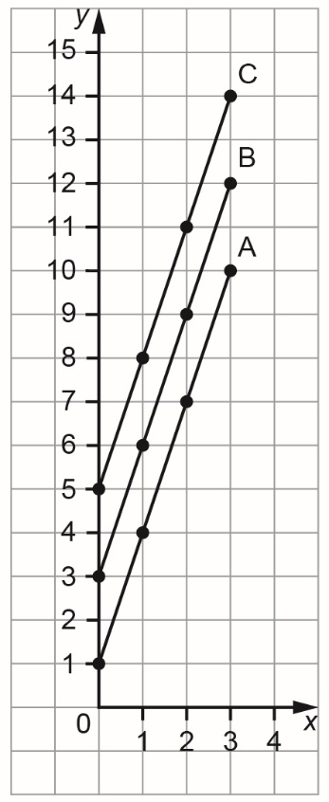
b) Graph each pattern on the grid
provided. Join each set of points
with a line.

c) How do the expressions compare?
How do the lines on the graph
compare?
The expressions have the same
number in front of x, 3, but the number
added is different each time.
Each line starts at a different
point on the vertical axis.
The number added tells you
the initial value.
The points on each graph move
up as you move right.
Every time x increases
by 1, y increases by 3.
The lines all have the same
steepness.
They are parallel.
The number in front of x tells you
the constant change.

