Number
Unit 2 Line Master 1a
Number Lines 1

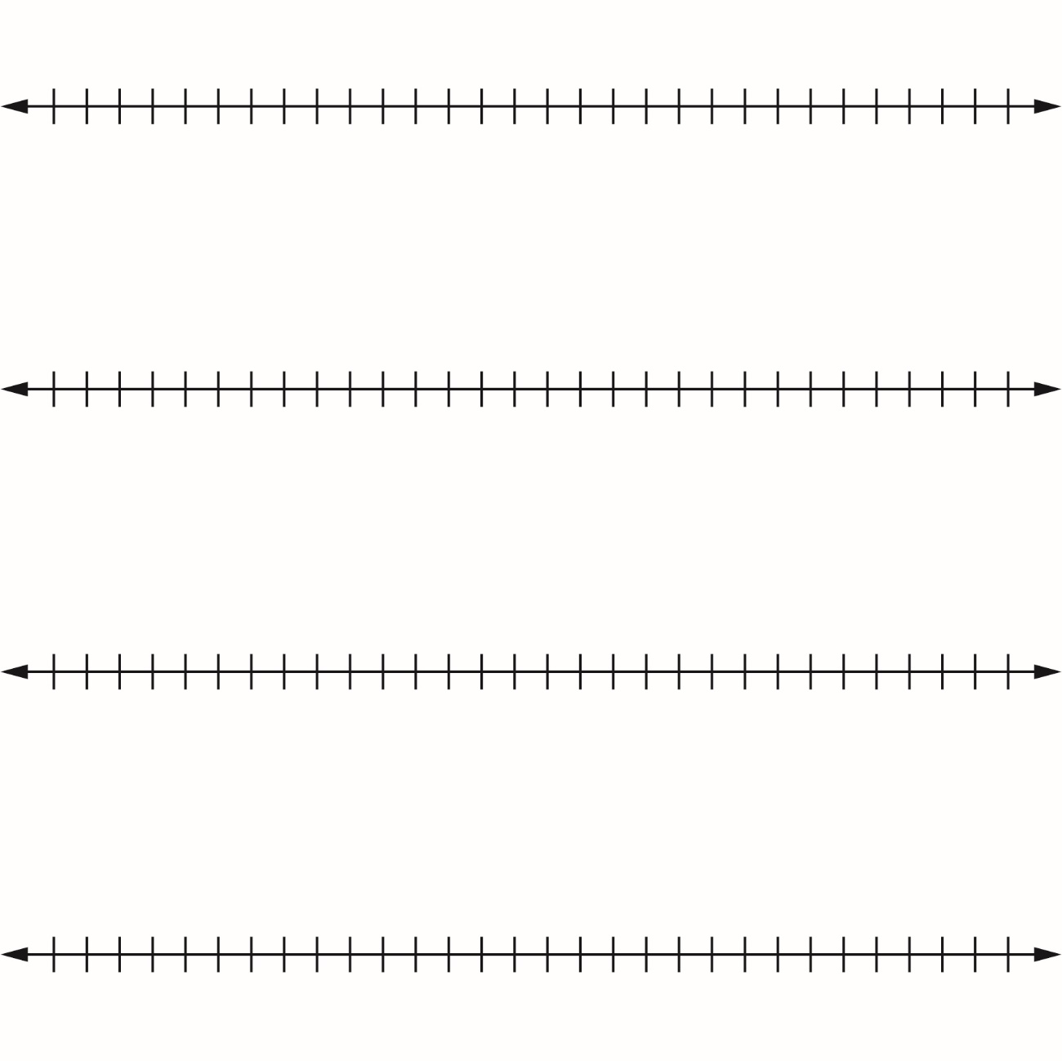

Number
Unit 2 Line Master 1b
Number Lines 2

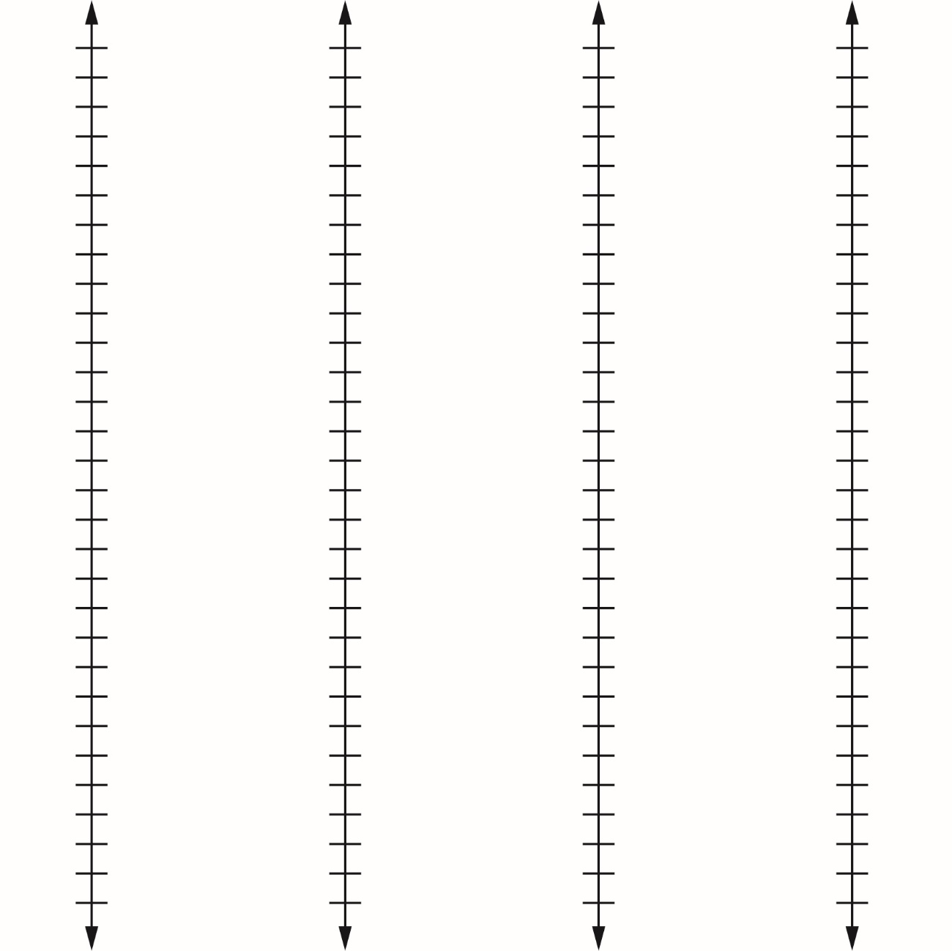

Number
Unit 2 Line Master 1c
Number Lines 3

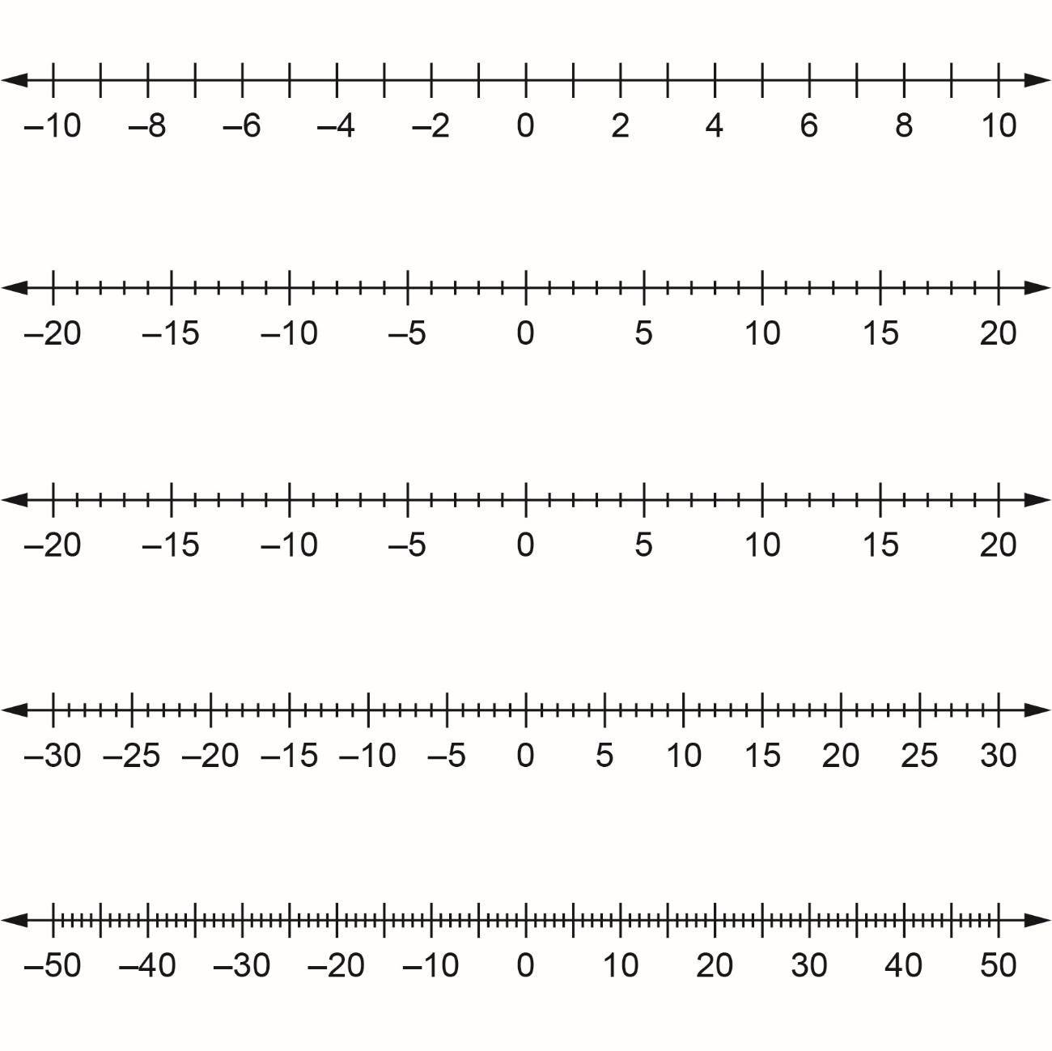

Number
Unit 2 Line Master 1d
Number Lines 4

