Plotting and Reading Coordinates
Describes the location of 2-D shape/objects on the grid.  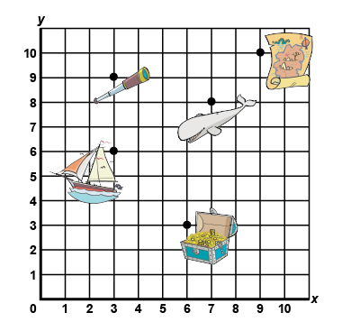  “The treasure chest is located at (6,3).” | Plots given points on a grid using a scale of one.  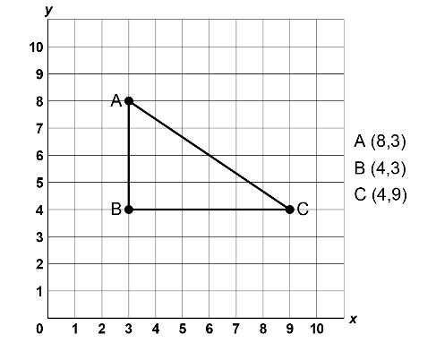  “I plotted the points, then joined them to form Triangle ABC.” | Plots and locates points on a grid using various scales and labels the coordinates.  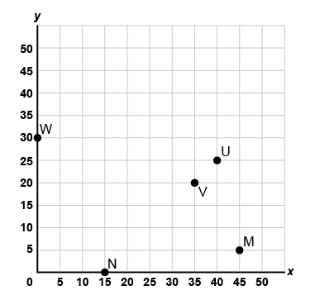  “To plot each point, I counted by 5s along each axis and labelled the coordinates: W(0,30),  N(15,0), V(35,20), U(40,25), M(45,5).” | Plots and locates points that lie between grid lines.  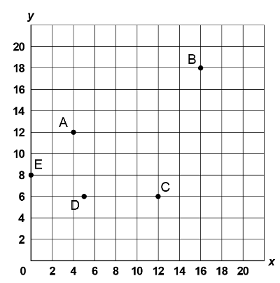  “The x-coordinate of D is halfway between 4 and 6, which is 5.  So, D has coordinates (5, 6).”
Observations/Documentation

